Out on the Pull: how small firms are making themselves sexy with new online promotion techniques

Lisa Harris (l.j.harris@soton.ac.uk )
Alan Rae (alan.rae@aiconsultants.co.uk )
Simran Grewal (s.k.grewal@bath.ac.uk )

Lisa Harris is a Senior Lecturer in Marketing at Southampton University School of Management. She is a Chartered Marketer and a member of the Chartered Institute of Marketing International Board of Trustees. Before joining the education sector she worked for 10 years in marketing roles within the international banking industry.

Alan Rae is Managing Partner of AI Consultants which researches how small companies use IT and the internet and develops training programmes for small companies themselves or those who need to work with or sell to them. He is a Fellow of the CIM and sits on its Professional Body Board. Since 1977 he has worked in Engineering, IT and Business Consultancy, mostly as an owner-manager.

Simran Grewal is a Lecturer in Organisational Behaviour at Bath University School of Management. She holds a joint award with Lisa Harris for teaching excellence. Her doctoral thesis explored the diffusion of e-mediated learning technology in UK Higher Education and her current research interests include the impact of web technology on social relations and networking behaviour in Web 2.0.

Keywords

SMEs, Web 2.0, online marketing, social networking, blogging,

Abstract

We examine the range of online marketing options that are now available to small businesses, and demonstrate how the sands are shifting from ‘push’ communications based on email, to ‘pull’ technologies such as Really Simple Syndication (RSS) where customers choose precisely which promotional messages to receive and which to reject. We draw upon the early results of an ongoing research project investigating how ‘early adopter’ small firms are using these new technologies.

We discuss the problems faced by small businesses in promoting themselves on limited budgets, and we consider how the so-called ‘Web 2.0’ technologies such as RSS, social networks, video and blogs are transforming the online marketing landscape for the proactive firms in our study. We conclude that the ‘early adopters’ we profiled are starting to develop expertise and fluency in how these tools can be used, successfully promoting their businesses and generating competitive advantage by ‘punching above their weight’ online.

Out on the Pull: how small firms are making themselves sexy with new online marketing techniques

Introduction

In this paper we examine the range of online marketing options that are now available to small businesses, and demonstrate how the sands are shifting from ‘push’ communications based on email, to an emphasis on ‘pull’ technologies such as Really Simple Syndication (RSS) where customers can choose precisely which promotional messages to receive and which to reject. These changes are enabling the ‘early adopter’ businesses that we studied to ‘punch above their weight’ in terms of building their profile and reputation in their dealings with larger competitors and customers.

Our findings are based upon the early results of an ongoing research project which is investigating how small firms use new technologies. Our research has identified a number of case studies from early adopters of Web 2.0 marketing techniques on which we will focus in this paper. This field of online marketing is very new and so its implications have yet to be subjected to serious academic study, so a number of possible avenues of further research are highlighted. Web 2.0 has been defined as ‘a group of economically, socially and technologically driven changes in attitudes, tools and applications that are allowing the web to become the next platform for communication, collaboration, community and collaborative learning’ (Angrignon, 2007). The tools that are currently popular include RSS, blogs and social networks and they provide opportunities for businesses to interact and share information with their customers in creative and inexpensive ways.

The analysis that we put forward is based on the following main strands of evidence:

Telephone survey | Completed by 400 SMEs in West London from the food, logistics, Internet and media sectors. There were 205 micro businesses, 140 companies between 10 & 49 employees and 33 companies between 50 and 249.
In depth interviews | 30 detailed case studies compiled of ‘early adopter’ firms using new online marketing (Web 2.0) techniques

We begin by discussing the problems faced by our small business case studies in promoting their products and services on limited budgets, and we then consider how Web 2.0 tools are transforming the online marketing landscape for the proactive firms in our study. We conclude from our analysis that the ‘early adopters’ we profiled are starting to develop some fluency in how these tools can be used in order to ‘punch above their weight’ by appearing to be more dominant in their sector than they perhaps really are. Our research also found that competency in Web 2.0 marketing offers these firms a critical skills advantage when competing with larger organisations whose managers are often prevented by their IT departments from dabbling in ‘amateur’ or ‘experimental’ web-based technologies.

Online marketing by small businesses

The SME sector accounts for 46.8% of employment and 36.4% of total turnover in the UK (Small Business Service, 2006). SMEs are therefore an important component of the economy, but research shows that they tend to fail at a disproportionately higher rate than larger firms. Historically, SMEs have been shown to struggle under resource constraints; often lacking capital, skills and technical knowledge which means that their investments in new technology can offer disappointing returns (Levy and Powell, 2003; Simpson and Docherty, 2004; Fillis et al., 2004). Our research suggests that Web 2.0 technologies offer SMEs the opportunity to help overcome these traditional barriers. In general terms, the Internet provides leverage for small businesses because it has massively reduced the cost of marketing versus the traditional promotional mix. More specifically, it has created mechanisms whereby individuals can make use of other people’s connections to raise their own business profile in systematic ways. The gradual growth in understanding of how online marketing works has allowed ‘early adopter’ SMEs who understand the principles to ‘punch above their weight’ in a competitive environment.

In our research we have interviewed owner managers from a number of these firms, and they observed that their main difficulty is that while they are delivering they can’t sell, and while they’re selling they can’t deliver. They have found a way out of this dilemma by effectively automating the prospecting process so that a flow of warm, qualified leads is generated as inexpensively as possible. They described how the Internet gives small businesses the opportunity to get much more leverage than was possible in earlier times, for example the website can be used as the ‘hub’ of a marketing ‘wheel’ which allows qualified sales and enquiries to be generated. However, customers do not easily find the website on their own – they have to be driven there. In essence, the business has to come to terms with the fundamentals of marketing, which is a matter of working out what the ‘story’ is that connects it with its key set of customers and then going about the business of telling it to them as part of an integrated marketing campaign, (Burns 2007).

Figure 1 is derived from our analysis of the marketing activities carried out by our case study firms and it demonstrates how this strategy can be implemented. The process involves integrating the data from trial ‘pay per click’ promotional campaigns with Google Adwords to illustrate where the keyword flows are, and what words and phrases the customers and prospects associate with the products or services that the firm wants to offer. Once these key words are established they can be used to support a promotional campaign which integrates face to face activity, written materials rich in keywords and the full gamut of online activities which is likely to include a website, email shots, e-zines, a blog and links from other sites with relevant content or offers.

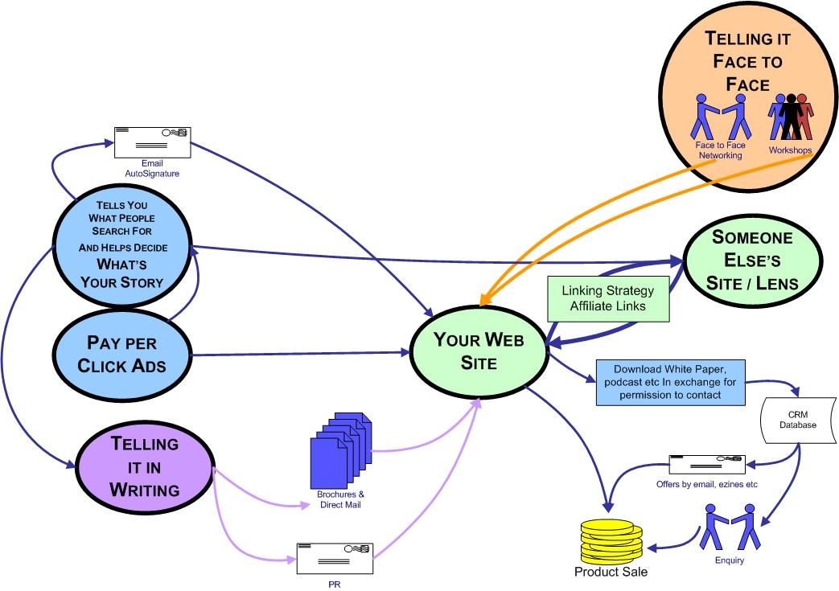

Figure 1 - How firms are using the Internet to tell their ‘story’ effectively.

Our diagram also illustrates the use of PR (which the more sophisticated small businesses that we interviewed saw as a key plank in their marketing strategy) as well as the traditional brochure and direct mail activities. The website activity is split into two routes – one is for direct sales where products are involved. This may be a pure online business such as one of our case study businesses selling plants on the Internet, which focused its marketing activities largely on a combination of ‘pay per click’ with Google Adwords and PR. The other route, which was demonstrated by the service businesses in our sample, involved download of white papers to boost the credibility of the business by showcasing its expertise to potential customers. This was often carried out for free in exchange for permission to contact by email and make further offers. Our interviewees noted that the approach does require a suitable customer relationship management system (CRM) and some idea of an ongoing communication strategy to make it work. Some firms used ‘autoresponders’ which are available inexpensively to take the drudgery out of this. Others preferred the flexibility that careful segmentation gave them. Selling services, however, tended to involve an element of face to face activity as well. While the aim of the online promotional activity was to generate a constant flow of warm leads, the opening and closing of the formal part of the sales process usually required face to face selling. It is no accident that many of the early adopters interviewed in our project had very good communication and inter-personal skills and hence they were accomplished at both online and offline networking.

Building on these general principles of online marketing described above that are practised in all of our case study firms, our research has also established that there are a number of fundamental insights and technologies allowing the most creative firms to take advantage of the tools of what has become known as Web 2.0 to make themselves appear larger, more competent and more important than their peers (and maybe than they really are). We will now examine some of these new marketing applications in more detail, integrating relevant theory with the specific examples from our primary research.

Search engine optimisation

The fundamental insight in understanding of the Internet was the ‘small world’ discovery which proposed that everyone in the world was connected to everyone else in 6 jumps (Milgram 1967). The same is true of all pages on the Internet but the corresponding figure is 19 (Barbarasi 2002). However, not all of the individuals are connected equally – some are very much more densely connected than others. Watts and Strogatz (1998) discovered that introducing a few random links into an otherwise structured network caused a dramatic reduction in the degrees of connection needed to link all the members. Gladwell (2000) popularised the dynamics of how these small world connections operate and popularised the idea of the ‘Dunbar number’. Anthropologist Robert Dunbar (1992) is quoted widely as stating that the human brain is only capable of handling a maximum of approximately 150 active social connections. It is theorised in evolutionary psychology that this number may be some kind of limit on average human ability to recognise members and track emotional facts about all members of a group. The combination of random links and clustering allows considerable leverage can be achieved by small firm marketers who understand that they have to align themselves with the key node points in the relevant online network if they want to spread their messages and ideas as widely and cost-effectively as possible. The 2nd most connected has half the connections of the leader, the 4th has a quarter, the 10th has a 10th and so forth. This principle is built into the algorithm that Google uses to assign the ranking of organic search results which is a logarithmic index of how well connected and respected is the page from which a link to a website originates. Understanding the implications of these network effects in terms of the online visibility of a business is critical to the understanding of search engine optimisation.

For instance, one of our case study companies, www.howtodobusiness.com is in the business of offering marketing tools to small businesses, and its strategy for search engine optimisation is as follows. To boost its Google ranking position, the business owner has a blog and writes articles for publication on Microsoft Academy which has a high page rank and Alexa Ranking (Amazon’s search engine). Google will see that there is a relevant link to HowtodoBusiness from a page with a good page rank and a good Alexa Ranking, and so it will gain an advantage in organic search over other pages that are not so well connected. This means that Google users looking for marketing tools will see the HowtodoBusiness website displayed more prominently in their search results than competing websites, and hence they are more likely to choose it over the competition. Google therefore operates by favouring pages that are connected to pages that it ranks highly because they have good content and lots of connections. This tends to promote a situation where there are a few massively popular sites, millions of ‘tiddlers’ and not much in between. This phenomenon was christened the ‘Long Tail’ in a widely cited article in Wired (Anderson 2004). It means that many can play but few can stand out much. Figure 2 applies the long tail principle to the blogosphere to demonstrate the dramatic effect that being favoured and well linked to can have.


Figure 2 – The long tail principle as applied to the blogosphere (www.technorati.com )

In a later section of this paper we will discuss how some of our case study firms are raising their Google rankings through blogging. A network effect as described above can also be created if other bloggers link to a post on the business owner’s blog, and if he himself makes a comment on another person’s blog. Seth Godin (2007) usefully describes blogs as ‘Google magnets’ for this reason.

Another of our case study firms, www.plants4presents.com, has made good use of these search engine optimisation techniques with Google Adwords to establish the optimum keywords for the business. A modest advertising spend of around £5 per day drove ‘pay per click’ traffic to the website, and it also enabled the owner to establish exactly which words and phrases the target customers were actually using to find the site. These words were then fed back into the titles, headlines and body copy of the website and into the anchor text of links on other peoples sites, and in autosignatures on blogs and emails, thereby maximising the chances of the site being found via an organic search rather than visitors having to be paid for through Google Adwords.

Online networking

There is academic consensus on the importance of creating efficient networks for establishing a business and its ongoing growth and success (Deakins and Freel 2003, Wilson and Stokes 2004). Researchers argue that the ‘network success hypothesis’ (Bruderl and Preisendorfer 1998) underpins business success as individuals are able to access resources at a reduced rate through networks, and at times gain access to resources that might otherwise not be available to them (Witt 2004). Networking can also aid the development of a firm’s credibility, expand the customer base and supplier contacts, highlight access to resources and available funding, encourage innovation and help develop strategic partnerships. It extends the reach of the business through enhancing survivability and by supplementing the entrepreneur’s own business resources to improve the likelihood of success (Zontanos and Anderson 2004).

Many business networks are now being formed and carried out wholly in cyberspace, making geographical location far less important for effective business networking than before. With Internet sites developing rapidly in the field of networking, and other related technologies such as e-mail and VOIP creating easy, fast and low-cost methods of maintaining and developing new contacts on a world-wide basis, online networking is an area that is impacting upon small businesses quite significantly. Thus teleconferencing facilities have reduced the need for travel to meet face to face, and new VOIP (Voice over Internet Protocol) software such as Skype make phone calls world-wide nominally free to users who are all subscribed to the same service.

Figure 3 has been derived from our analysis of the online networking activities of our early adopter case study firms. It builds on the basic online marketing activity we documented that was illustrated in Figure 1.

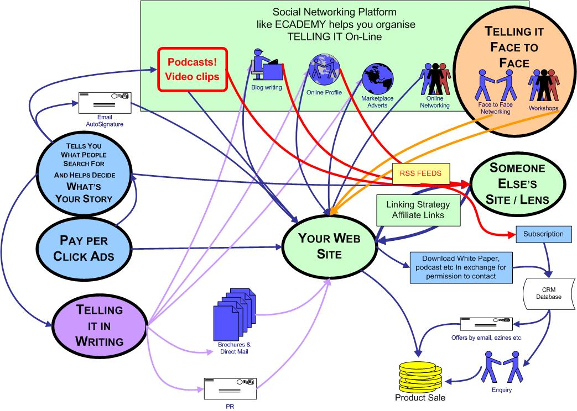

Figure 3 – The incorporation of online networking into the marketing mix

As you can see, for these firms in our sample, the basic model is amplified by podcasting, embedded video clips, blogs and the use of online social networks. These networks enable participants to blog, join clubs, hold discussions and build quite a sophisticated online presence for subscriptions which are often free or at worst quite modest. Many of our case study firms belonged to Ecademy (www.ecademy.com), which is an online networking platform with 150,000 members around the world. It uniquely combines a substantial offline face to face networking component with its online offer. The most sophisticated social networking sites like Ecademy incorporate software to hold online discussions and meetings, allowing many people to login without having to move from their desk. Internet networking maintenance can be easier than face-to-face or telephone interaction due to the online tools that are accessible any time of day and night; web pages, e-mail and chat rooms. These technologies provide instant access to a diverse network of individuals globally which allows networks to be broadened and strengthened, thereby overcoming many of the limitations of traditional face-to-face networking such as small network size and lack of diversity (Zontanos and Anderson 2004).

So for the right type of knowledge business there is a real opportunity with online networking. For example, from our early adopter cases, Westhaven Logistics has built a presence in the Ecademy environment to enhance the development of the business towards import-export by using some of the more advanced technologies available to build a core group of collaborators. The Video Internet company has made effective use of online and offline networking techniques and Actors Inc offered show reels and on-line presence for Actors on its site. It facilitates agents casting and offers Skype as a core part of its offer, and it is just a 2 man business. HowtodoBusiness has generated 4000 ‘opt in’ e-mail addresses for promotional purposes over a 2 year period for a ‘pay per click’ spend of £3200. Currently, about half of the pay per click budget is paid for by sales of created products, while the entire budget was covered by 1 consultancy order obtained.

Blogs

Another particularly important issue to emerge from our research was the extent to which these online networks, with an ethos of mutual support amongst their members, act as ‘Web 2.0 incubators’ in which participants learn to make their on-line presence more attractive, and go through the process of learning to blog, a process which can be described as the on-line equivalent of PR. A number of companies following this route were to be found in our sample. For example, Personal Chef largely promoted herself through Ecademy and is a well-known - if sometimes rather an eccentric - blogger. London Cakes have a very limited IT infrastructure but this has not stopped them from developing their Internet offering with some unusual added value services such as an effective sequential email campaign to promote specialist cakes for Valentine’s Day. As Hewitt (2006) notes, by writing their own blogs the business owner is able to build credibility and ‘showcase’ their expertise. If customers find the blog useful, they can set up an RSS link so that they automatically receive future postings from that source or updates to existing ones – a classic example of ‘pull’ rather than ‘push’ marketing, and a trend that we noted in the introduction to this article and will develop further in the next section.

According to Weil (2006) a blog differs from online diaries or web pages in that it is more collaboratively constructed, interactive, frequently updated and written in a conversational voice. Our interviewees demonstrated that blogs can be created by small businesses to present information to customers and stakeholders and build a relationship with them. However, traditional controlled, one-way communication does not work with blogs and it is essential to be prepared to learn, listen and ask people what they think. The content should come across as passionate and authentic, be written in the language of the target audience and the writer needs to be willing to acknowledge any mistakes. Fathelrahamn and Shafaghi, (2007) note that a blog is not ‘company speak’, instead it is like a window through which a company allows its customers to see inside.

Crucially, the blogger needs to have something useful to say because customers can choose what they want to read, what they want to talk about and with whom they want to build up a relationship. The reality of today’s marketplace is that customers have a choice, and they can certainly choose to ignore you! Thus customers have to be given something real, new and exciting on a regular basis. If they are compelling enough, ideas and messages can be spread like viruses (Scoble and Israel, 2006; Gladwell, 2000). A blog with quality content will naturally have a greater attraction for readers and thus a greater effectiveness as a vehicle for spreading the intended promotional messages. Blogs can therefore be regarded as a viral marketing tool, but with the huge advantage that they facilitate multi-directional communication. Traditional viral marketing campaigns, using contests, games or video clips as content are one-way instruments which might spread well for a certain period of time but ultimately lose their impact as no real relationship is derived (Wright 2006). According to Bricklin (2002), small businesses in particular can generate competitive advantage through blogging:

‘In many cases, it is the intimate personal nature of a blog that can help to establish and maintain a relationship with an existing or potential customer. For many small firms a personal relationship is their main difference from a “faceless” large corporate.’

Increasingly, the virtual world is being monitored by search and tracking sites looking for keywords being mentioned in blog postings. Some of our early adopter businesses (for example HowtodoBusiness and Plants for Presents) were also monitoring other bloggers in their industry as an effective ongoing process of market research, allowing them to see what people are talking about, what trends are developing and obtaining real-time feedback.

Really Simple Syndication (RSS)

Email marketing increasingly has to cope with the resentment of individuals against intrusive marketing, and the rising tide of legislation against unsolicited marketing that applies in both European and US jurisdictions. While people can easily throw unwanted junk mail away it is more difficult to avoid insistent emails or telephone calls. The tools available are unsatisfactory – there is plenty of anecdotal evidence of perfectly respectable emails being caught in company spam filters and not delivered, and the defences against intrusive telephone calls are largely all or nothing. So, rather than risk their email messages being perceived as spam, some of our early adopter companies are looking at ways that enable their story to be picked up only by people who are really interested in what they have to offer or say.

One of the key tools for achieving this is the RSS feed which essentially takes the form of a headline and a body of text. According to the BBC, itself a good example of RSS in action, an RSS feed is a stream of updated information sourced from a blog or website, which lets an RSS Reader know that an update has happened. RSS readers are now available in all the major Internet browsers and search engines such as Google, Yahoo, AOL and MSN. When the RSS reader sees an update (for which it is constantly scanning), it takes the headline, or the headline and some of the content, or the headline and ALL of the content and displays it. Once the feed is set up, there is a direct, permanent, updated connection to a source of content. It means that people can choose to stay in touch with anyone who interests them and who is making relevant communication available to them. See http://news.bbc.co.uk/1/hi/help/3223484.stm#whatisrss for more detail on this topic.

From the point of view of the small business, the activities of our early adopters demonstrate that the crucial task is to move the company mindset from collecting potential customers’ email addresses and then following up with emails and e-zines, to encouraging prospective customers to sign up to a blog via an RSS feed. Subscribers will then be automatically notified of anything that the marketer may choose to post - about events that are being run, free downloads, workshops, new products, relevant observations and worthwhile links that they will find interesting. Godin’s basic principles of permission marketing (1999) are still adhered to, but control over the extent and duration of permission is firmly under the control of the customer. Consequently the risk to the business of its messages being perceived as spam is reduced.

In his more recent e-book Flipping the Funnel (2006), Seth Godin outlines his strategy of creating a platform to allow advocates to tell the story of the business. He has created a platform to allow others to build this structure in an online network called Squidoo (www.squidoo.com). This is a content aggregation tool which allows participants to build a ‘lens’ so that they can focus their expertise and build credibility with prospective customers. It is essentially an additional one page site which can be used to drive traffic back to the main company website. There are two innovative aspects to this. One is that it is designed to pick up RSS feeds from, for example, special interest clubs on a online networking platform like Ecademy. The second is that the firm is able to create an HQ lens under which other lenses can be aggregated. As well as using this to build an ‘empire’ of knowledge, the cunning marketer can create a template to sit under his headquarters, to be made available to customers and other advocates to tell the ‘story’ for them. These features are used by a number of our case study firms and is particularly important for the small ‘knowledge economy’ business wanting to broadcast its ideas. It is a more sophisticated approach to viral marketing than the current fashion for creating trivial games and circulating them around the world’s email networks.



Figure 4 - Martin Bamford’s Squidoo lens

One of our interviewees who uses these tools effectively is Martin Bamford, an IFA based in Surrey. He has used Ecademy to promote his business and was one of the earliest to use Squidoo as a platform, as illustrated in Figure 4. He has also created a ‘Squidoo club’ on Ecademy. The key point is that this material can be easily created by small businesses with free blogging software and effectively fed to strategic points such as the website front page using RSS where, as noted earlier, interested parties can elect to pick up the feed and automatically receive any further words of wisdom or other communication that originate from that source. Some of the key spaces for amateurs to ‘dip their toes’ into the world of blogging are already RSS enabled in this way. In another of our case studies, the owner of HowtodoBusiness can pick up a blog discussion thread that is going on in an Ecademy club, and reproduce it in Squidoo as www.squidoo.com/howtodobusiness. This effectively means that he can make the same information appear in various different locations, all of which can be arranged to point back to the same source. This boosts traffic to the website and hence its Google page ranking and makes the business appear bigger and more influential than it actually is. As a bonus, HowtodoBusiness has links with the appropriate anchor text keywords embedded in the blog material that the owner posts on Ecademy, which also has the effect of improving its page ranking. This is because Ecademy is itself well connected so there is a ‘halo effect’ that reflects back to the business’s own website which also helps to build the Google profile.

Discussion

It is rare for the small businesses that we interviewed to have an integrated relationship marketing and sales methodology in place. Partly this is because in most of these organisations only the principal or other senior individual is involved in selling directly, or they find the offerings on the market too complex or ‘clunky’ for their needs. In general, most firms find that a little marketing goes a long way and because they are run holistically, it is more important to generate just enough enquiries for the sales pipeline than to generate more enquiries than they can practically fulfil. The individuals we spoke to – like most owner managers - are consciously performing a balancing act with their companies every day of their lives.

Despite these difficult issues, we believe our research has quite clearly established that exposure to the currently evolving tools of the Internet means that small businesses have an advantage because they can take for granted modalities and means of communication that are often denied to people operating in the corporate and public sector environments. Effective small business marketers are becoming immersed in a range of simple and affordable techniques which are leaving their corporate cousins behind - hampered as the latter are by the ‘protection’ of their IT departments. Most IT professionals are trained to build impervious protection systems for the integrity of the data of the organisations for which they work. This means that their default approach is to lock down and deny access to tools and new software unless a strong business case is made. As a result, access to Skype, instant messaging, and blogging is off limits, and quite often even sound cards are not available, so that the joys of Youtube and viral marketing are denied to the workers in the corporate ant-heap. Our research indicates that this is starting to put larger organisations at something of a competitive disadvantage, while allowing more flexible small businesses to use the new promotional tools as we have described above in order to ‘punch above their weight’. It also has the result of limiting the effectiveness of how large corporate organisations can understand what is really going on in the Web 2.0 area, since being able to deploy these tools properly requires a certain critical mass of understanding about how they operate. This poses certain educational issues for many marketers in the corporate arena.

In summary, the following table illustrates the particular ways in which our case study businesses are experimenting with Web 2.0 marketing applications. The numbers look impressive but clearly they cannot be regarded as representative because our research focused upon early adopter businesses. The next phase of our research will attempt to track how far into the mainstream of marketing activity these applications are reaching.

SME | Blog | RSS | Google adwords | Social networking | podcasts
1 | X | X |  | X
2 |  | X | X | X
3 | X | X | X | X | X
4 | X | X |  | X
5 | X | X | X | X
6 | X | X
7 |  | X | X | X
8 |  | X
9 | X | X | X | X
10 | X | X | X | X | X
11 |  | X | X
12 | X | X |  | X
13 | X | X |  | X
14 | X | X | X | X
15 | X | X | X
16 |  | X |  | X | X
17 |  | X | X
18 | X | X |  | X
19 | X | X | X | X
20 |  | X | X | X | X

So far we have focused upon the new online marketing tools that our case study firms are adopting in order to grow their businesses. Moving on now to consider the ‘bigger picture’, our research has also indicated that there are two main routes that small businesses follow as they get bigger and have to deal with the issues associated with developing a more formal IT infrastructure. These findings are illustrated in Figure 5.

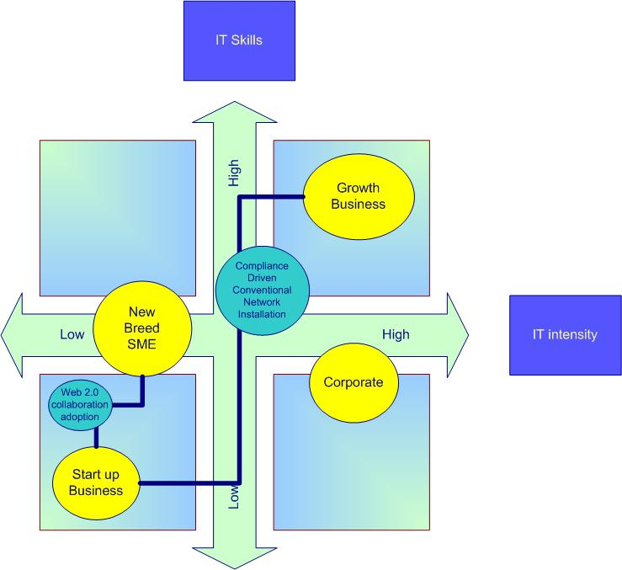

Figure 5 – the route to growth for ‘new breed SMEs’ compared with traditional IT requirements

This matrix illustrates the level of IT skills versus the intensity of IT investment. Some of our case study businesses are following the traditional route of investing in a proper ‘in house’ network server at an early stage in their growth, driven in that direction by external pressures such as the demands of major customers, suppliers or other stakeholders. Pursuing this strategy tends to require a general upgrade in IT skills within the firm, together with an increasing reliance on IT vendors for more complex systems and specialist computing knowledge as the business grows. One of the reasons that some of our case study firms are avoiding investment in IT infrastructure is not so much the cost of the equipment but the cost of purchasing technical support, combined with fear of what happens if the implementation hits problems. With technical support for a network installation running at £800 per day, this can be something of a blow for small businesses, particularly if it looks like becoming open-ended. The other fear is, of course, the sheer damage and loss of vital management time that a botched implementation might result in. This factor was mentioned as a major deterrent by most of our interviewees.

However, our research has also indicated that we are seeing the emergence of an innovative group of small firms (labelled as ‘new breed SME’ in Figure 5) who will seek to use the tools of Web 2.0, flexible working and the judicious use of external hosted services to postpone having to put a server in; not only because of the cost, but because of having to support a greater level of complexity in the business than is strictly operationally necessary. The profile of these firms that we have studied suggests that they are prepared to develop their own IT skills, supported by organisations such as Ecademy, and become ‘gifted amateurs’ using Web 2.0 marketing techniques discussed in this paper, ahead of their propensity to invest in additional hardware and technical support in the more traditional manner described above. For these businesses, Web 2.0 technologies are being deployed way beyond their basic promotional role into the very infrastructure and strategy of the firm. We discuss in more detail in another paper the implications of this policy for business growth.

As noted earlier in the paper, in some of our case studies the online networking came first, and this experience provided the business owners with an introduction to and examples of the Web 2.0 approach which they subsequently adopted themselves. We believe that if our research were to be extended to the business services sector we would observe a much greater prevalence of this particular pattern – ie advanced web-based marketing activity by gifted amateurs without the need for a server and other specialised equipment and knowledge. If this trend continues, there are clear implications for technology vendors seeking to encourage small firms to invest in expensive and complex IT ‘solutions’. The next phase of our research will test out these ideas more definitively across a broader range of market sectors.

Conclusions

Bringing together the activities undertaken by our early adopter case studies that we have discussed in this paper, the key to making a success of a Web 2.0 marketing communications strategy can be summarised as follows:

- Have interesting content – regularly refreshed
- Have the back up mechanisms available to turn other people’s interest into money
- Make sure that you create as many links as you can to appear as widely as you can and encourage referral back to your site
- Be prepared to engage with customers in their language and deal with the negative feedback in a proactive way as well as the positive
- Accept that promotional messages can no longer be ‘controlled’ along the lines of a traditional press release
- Avoid cluttering your customers’ inboxes with unwanted email. Instead provide the mechanism for them to ‘pull’ your content themselves by RSS.

These are the initial steps on moving from a traditional ‘push’ to a contemporary ‘pull’ marketing regime. Obviously this approach cannot work in isolation, and so it needs to be backed up by offline techniques like postcards, PR and on line advertising as well as whatever face to face marketing fits the business model. The ‘early adopters’ that we profiled are starting to develop some fluency in how these tools can be used, and are moving successfully beyond the basics. We have shown that in addition to allowing these businesses to ‘punch above their weight’ by appearing to be more dominant in their sector than they really are (for example by effective search engine optimisation) competency in Web 2.0 marketing also offers these firms a skills advantage when competing with larger organisations whose managers are often prevented by their IT departments from engaging in such activities. We will be returning to some of these businesses at a later stage of the project in order to provide a longitudinal element to our research. Based on the lessons now being learned from early adopters’ positive experiences with these new tools, we predict healthy growth in the numbers of small businesses ‘punching above their weight’ by going ‘out on the pull’ in this way.

References
Anderson, C. (2004) ‘The Long Tail’ Wired
Angrignon, T. (2007) ‘Defining Web 2.0’ www.troyangrignon.com/blog/web20
Barabasi, A-L. (2003) ‘Linked - How Everything is Connected to Everything Else and What it Means for Business, Science, and Everyday Life.’ Plume.
Bricklin, D. (2002) ‘Small business blogging’ available from http://danbricklin.com/log/businessblogging.htm
Bruderl, J. and Preisendorfer, P. (1998) ‘Network support and the success of newly founded businesses’ Small Business Economics, 10; 213 – 225

Burns, P. (2007) 2nd Edition, ‘Entrepreneurship and small business’, Palgrave Macmillan

Deakins, D. & Freel, M. (2003) ‘Entrepreneurship and Small Firms’, 3rd Edition, Maidenhead: McGraw-Hill Education

Dunbar, R. (1992) ‘Neocortex size as a constraint on group size in primates,’ Journal of Human Evolution (1992), vol. 20, pp. 469-493.

Fathelrahamn, A. and Shafaghi, M. (2007) ‘Analyzing bloggers data on software design patterns and applications intetgration; methodology and implementation’
Information Management & Security Journal , Volume 15, Number 2, pp 84-101

Fillis, I., Johansson U. and Wagner, B. (2004), ‘A qualitative investigation of smaller firm e-business development’, Journal of Small Business and Enterprise Development, Vol. 11(3), pp. 349-361

Gladwell, M. (2000) ‘The Tipping Point’, New York: Little Brown

Godin, S. (2001) ‘Unleashing The Idea Virus’ New York: Hyperion

Godin, S. (2006) ‘Flipping the Funnel’ www.sethgodin.typepad.com

Godin, S. (2007) ‘Small Is the New Big: And 183 Other Riffs, Rants and Remarkable Business Ideas’ New York: Penguin Books

Hewitt, H. (2006) ‘Blog: Understanding the Information Reformation That's Changing Your World’. Nashville: Nelson Books.

Levy, M. and Powell, P. (2003), ‘Exploring SME Internet Adoption: Towards a Contingent Model’, Electronic Markets, Vol. 13(2), pp. 173-181

Milgram, ,S. (1967) ‘The Small World Problem’ Physiology Today 2 pp 60-67

Scoble, R. and Israel, S. (2006) ‘Naked Conversations: how blogs are changing the way businesses talk with customers’ New Jersey: John Wiley

Simpson, M. and Docherty, A. (2004), ‘E-commerce adoption support and advice for UK SMEs’, Journal of Small Business and Enterprise Development, Vol. 11, No. 3, pp. 315-328

Small Business Service (2006) available from
http://www.dti.gov.uk/bbf/small-business/research-and-statistics/statistics/page38563.html

Watts, D.J. and Strogatz, S.H. (1998) ‘Collective Dynamics of Small World Networks’ Nature 393 440-442

Weber, L. (2008) Marketing to the Social Web

Weil, D. (2006) ‘The Corporate Blogging’ New York: Penguin Group

Wilson, N.C. and Stokes, D. (2004) ‘Laments and serenades: relationship marketing and legitimation strategies for the cultural entrepreneur’ Qualitative Market Research: An International Journal Volume 7 No. 3, pp. 218-227

Witt, P. (2004) ‘Entrepreneurs networks and the success of start-ups’ Entrepreneurship and Regional Development, 391 – 412.

Wright, J. (2006) ‘Blog Marketing’ New York: McGraw-Hill
Zontanos, G. and Anderson, A. (2004) ‘Relationships, marketing and small business: an exploration of links in theory and practice’ Qualitative Market Research: An International Journal Volume 7 Number 3 2004 pp. 228-236

