3.8 Results and Discussion

The CBS 95 is a material that has been manufactured for the use within the automotive industry as body panels that provide a Class A surface finish with minimal preparation and no rework. This research is the first investigative work to characterise defects that were found in the Class A surface.

The defects that have been visually observed on the surface are summarised in Figure 3.25 and Table 3.4. These are then individually addressed in the subsequent sections. There are two additional defects that were found in the bonnets manufactured that were not discussed in the literature. These were worm tracks and teddy bears ears (worm tracks are localised rows of voids found at the edge of the DB9 bonnet and teddy bears ears is surface distortion on the surface surrounding the vents).

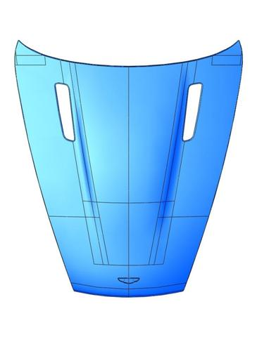
Porosity

Worm tracks

Fibre Bridging

Teddy Bears ears

Print through

Figure 3.25 – Schematic of the characteristic defects found in the DB9 Bonnets.

Bonnet No. | Defects Observed
1 | Porosity, Teddy bears ears, Kit defects and Print through
2 | Porosity, Teddy bears ears and Kit defects
3 | Porosity, Teddy bears ears and Kit defects
4 | Porosity, Worm tracks, Teddy bears ears and Kit defects
5 | Porosity, Worm tracks, and Teddy bears ears
6 | Porosity and Worm tracks
7 | Porosity and Worm tracks
8 | Porosity
9 | Porosity
10 | Porosity
Table 3.4 – Defects observed on the 10 bonnets.

3.8.1 Porosity: Sink Marks and Pin holing

Sink marks and pinholes are defects that have been witnessed on the surface of all of the bonnets in either the form of a sink mark or pinhole. The cause of these defects is believed to have the same origin: porosity. These defects are therefore discussed independently in the following paragraphs.

Figure 3.26 shows an image under the microscope of a sink mark in the surface of bonnet number 2. These cause significant issues as the surface is not deemed a Class A standard when a sink mark is present. The sink mark is circular in shape.
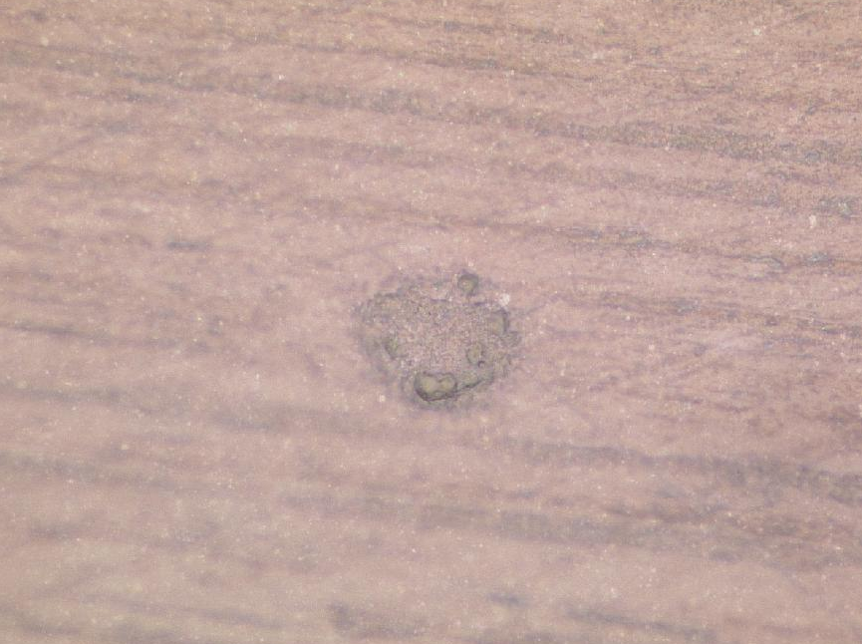
4μm
Figure 3.26 – Microscopic image of a sink mark in the surface of the CBS 95 (x50 magnification)

The sink mark was initially analysed using the Proscan technique. This quantifies the depth and geometry of the sink mark. Figure 3.27 shows the scanned image of the sink mark (Figure 3.26) in the surface of bonnet number 2. It can be seen on the lower right-hand side edge that there is a lip on the sink mark (the x-position contour line highlights this). The edges of the sink mark are higher than the surrounding surface indicating that at some stage during its formation the sink mark formed the shape of a sphere and therefore, bulged from the Class A surface rather than the dipped shape shown in Figure 3.26. This theory would suggest that the contents of the sink mark had expanded during the high temperature part of the cure cycle to form the circular shaped sink mark and then upon cooling contracted to its present form.

According to Norman and Stewart [58 and 60] at high temperatures voids form from moisture or air trapped within the laminate. This would correlate well with the findings above. Hence, if there was the formation of gases or the expansion of air at the high temperatures during the cure cycle, these would both contract during the cool step of the cure cycle, resulting (if located at the surface of the component) in a concave appearance on the surface.

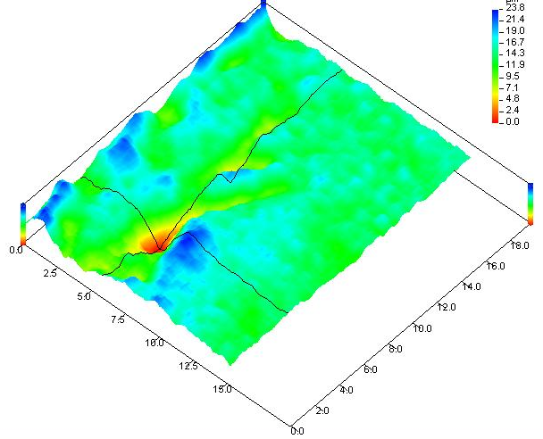
Figure 3.27 – Proscan image of the sink mark

From Figure 3.27 the sink mark measured 23.8μm deep. This defect was mounted in epoxy resin and polished using the automated polishing method (Section 3.7.2.2). The sample was then viewed underneath the microscope. Figure 3.28 shows the image at x200 magnification.

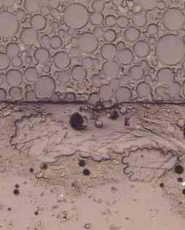
4μm
Mounting resin
Sink mark
Voids
Polyester fibres
Figure 3.28 – Microscopic image of surface film showing sink mark (Figure 3.26)(200x magnification)

Figure 3.28 shows the concave dip in the Class A surface of bonnet number 2, and underneath this area it can be seen that there are voids. This sample has been prepared (Figure 3.20 polishing method) for detailed examination under the microscope to achieve this view of the sink mark, it is possible that the voids could have been larger but the evidence has been removed during the preparation method of this sample. However, it is very clear that there are several voids in the close proximity of the sink mark at the surface. As the laminate would have cooled then these voids would have contracted and reduced significantly in size this causing the surface of the CBS 95 to sink in that concentrated area.

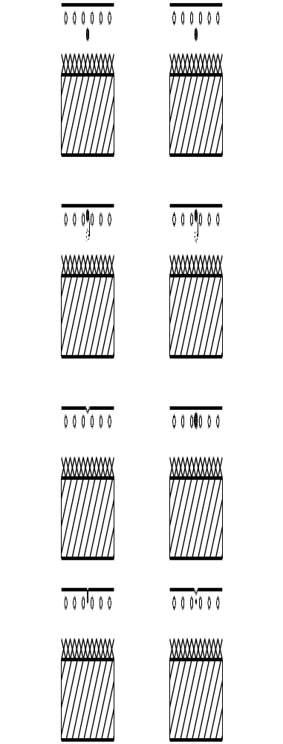
- Temperature: 25°C, void within the surface film resin

- Temperature: 85°C, the void migrates near to surface under the pull of the vacuum

- Temperature: 100-130°C, the void expands due to the increase in temperature

- Temperature: 25°C, the void contracts on cooling and “pulls” at the surface, which then creates the sink mark in the Class A surface

Figure 3.29 – Conceptual model describing the formation of the sink mark in the Class A surface of CBS 95

The behaviour of the CBS 95 is different to that of a traditional carbon fibre prepreg. Due to the surface structure of the CBS 95, when there is a void present it can behave in two different ways depending on its location within the surface film. In this particular case the void has not caused a hole in the Class A surface, but a dip. Figure 3.29 describes the conceptual model of the sink mark formation from porosity within the surface film. The model shows that air trapped or volatiles formed from the resin heating and dropping in viscosity during the cure cycle migrate to underneath the surface with the pull of the vacuum. As the temperature continues to increase the void will expand until maximum temperature is reached. Then when the cure is complete the temperature starts to reduce the void contracts and reduces in size, due to its location of just underneath the surface as the void contracts, it pulls the surface with it creating the sink mark in the Class A surface. Porosity can also be the cause of another form of defect on the Class A surface of CBS 95: pin holing.

The pin holing that has been seen is located at the edges of the bonnet. It is where the Class A surface curves to the edge and towards the Class B side of the bonnet. Figure 3.30 shows pin holing at the edge of the bonnet under the optical microscope.

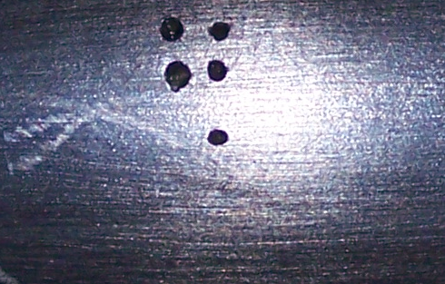
2μm
Figure 3.30 – Pin holing from the edge of the DB9 bonnet (curving to the Class B side as shown in location plan) x57 magnification

From Figure 3.30 it can be seen that the largest pinhole is only 1.5μm in diameter.
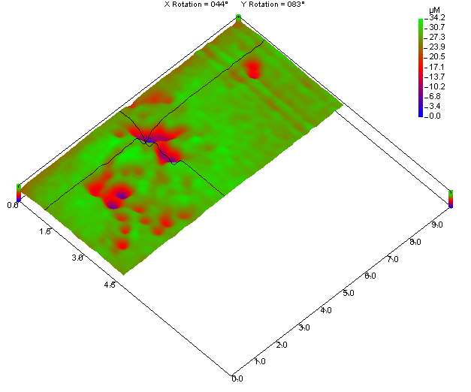
Figure 3.31 – Proscan image of pinholes

However, referring to Figure 3.31 the depth of the pinholes is equal and in some cases deeper (up to 34μm) than the depth of the sink marks at 23.8μm. This highlights the detrimental effect that the pin holing will have on the Class A surface. It is possible to fill these defects with polyester based filler. However, this has a different coefficient of thermal expansion. Therefore, when the component is heated subsequently for the paint process (Appendix 5.25) the polyester based filler will expand and contract differently to the CBS 95. This could leave potential witnessing on the Class A surface where the polyester filler has been used.

The cause of the pin holing was investigated using an SEM to gain a better understanding of the possible formation route. However, due to the small cluster of the pinholes, during the preparation stages it was impossible to produce the sample with the pinholes of adequate standard for analysis perpendicular to the Class A surface. This is due to the preparation process, which removes a nominal thickness from the edge of the specimen. Another method that was sought was the use of a X-TEK Bench top X-Ray Tomography Unit as this does not require the destruction of the sample. However, the tomography unit that is available is not powerful enough to achieve the resolution that was required to locate the pinholes to investigate their origin. This was disappointing and due to limitations and constraints further investigation into the initiation of pinholes had to be terminated for this section of research.

However, a conceptual model was postulated for the possible origin of pinholes using a similar model that was applied to the formation of a sink mark, as previously stated each of these defects initiate from porosity. Figure 3.32 describes the possible theory of the formation of the pinholes. The source of the void that is present in the resin is thought to be similar. The difference is during the heating section of the cure cycle the void migrates under the pull of the vacuum to under the surface, however; in this case the void is just under the surface. Therefore as the temperature increases to 130°C the void expands, as it is located just under the surface, the stress from the expansion must be enough to break the surface tension of the resin. Then as the resin starts to cool it “gels” and the void is fixed in that location. There will most likely be a slight movement creating a deeper pinhole on cooling, as the whole component contracts.

- Temperature: 25°C, void within the surface film resin

- Temperature: 85°C (minimum viscosity), the void migrates near to surface under the pull of the vacuum the surface tension is broken as the void is just under the surface

- Temperature: 130-100°C (resin has already started to gel – “thicken”), the void will remain in this location

- Temperature: 25°C, the void contracts on cooling and moves into the depth of the resin, however there is still an appearance of a “hole” in the Class A surface

Figure 3.32 – conceptual model describing the formation of the pinholes in the Class A surface of CBS 95

3.8.2 Worm tracks

Worm tracks have also been located at the edge of the bonnet. This description comes from there appearance, which is shown Figure 3.33.

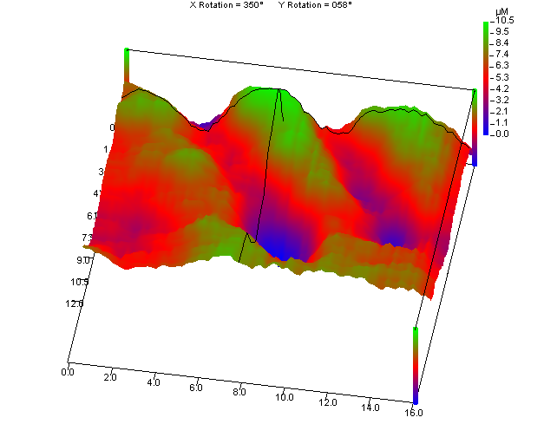
Figure 3.33 – Proscan image of worm tracks

As shown previously these defects were concentrated around the perimeter of the bonnet. They form striations running perpendicular to the edge of the bonnet. To understand the initiation of these worm tracks an area with a concentration of worm tracks was cut up and studied under the microscope. Figure 3.34 shows the micrograph of a worm track. Figure 3.35 shows that the worm track forms across the bonnet (left to right or right to left, depending on which side of the bonnet is being addressed), but migrating to the edge of the bonnet. Considering its location (edge of the bonnet), this is where majority of the air is dissipated from the component when the resin reaches minimum viscosity. Therefore, the formation of the worm tracks could be due to the dissipation of the air or volatiles through the edge of the bonnet and as the resin gels there is still air trying to dissipate from the component. This could indicate that a dwell may be required in the cure cycle (Figure 3.16), as currently there is no dwell.

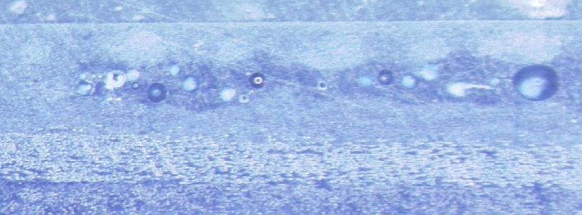
2μm
Surface
Polyester fibres
Glass fibre
Carbon fibre
Worm track
Figure 3.34 – Optical Microscopic image of worm track (57x magnification)

Figure 3.35 – Location of worm tracks on the bonnet

Additionally the presence of the worm tracks causes porosity on the edges of the bonnet. This has a knock on effect with the required edge condition of the bonnet (the edge condition is needed to meet the fender with perfect alignment - Figure 3.36).


Figure 3.36 – Example of edge condition at the bonnet/fender interface

Figure 3.37 shows the effect worm tracks have on the edge condition, it can be seen that the resin breaks down or crumbles as it contains pockets of air or volatiles so there is very low surface integrity to provide the desired geometric shape at this location on the bonnet. Therefore, the resin breaks down and the fibre layer in the surface film is left exposed.

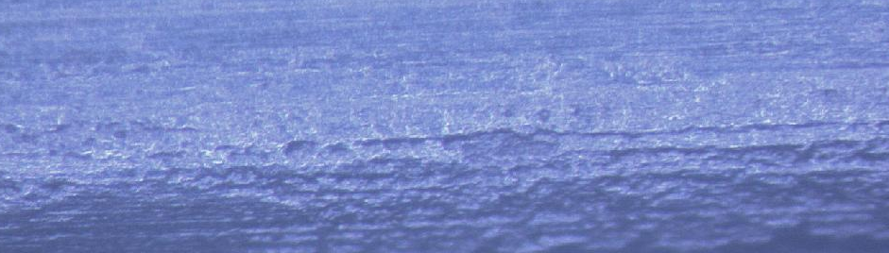
2μm
Figure 3.37 – Effect of worm track on the Class A surface (57x magnification on Optical Microscope)

3.8.3 Fibre Bridging

Figure 3.38 shows the surface imperfections around the badge detail on the DB9 bonnet, they are concentrated across the top and down the sides (where the white lines highlight the perimeter of the badge). It could be described as a faint crack line.

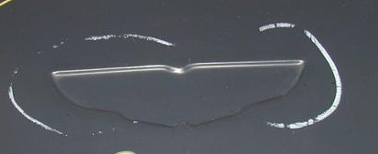 (a) 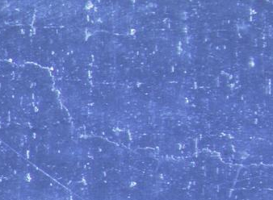 (b)
2μm
Figure 3.38 – Defects Around Badge geometry (a) Shows the area of the cracked line defect (Digital image) (b) Detailed image of defect (57x optical magnification)

This defect seems to only appear where there is curvature in the bonnet (the badge detail and the vents). A section from around the badge and the vents with the defect present was taken and cut perpendicular to the defect. This sample was polished and viewed under the microscope. Figure 3.39 shows the resulting image. The highlighted area shows that the fine glass scrim at the surface has migrated from its location just underneath the Class A surface and down into the surface film resin, bridging the geometric detail of the badge by curving away from the surface. The result of this is a resin rich pocket at the surface.

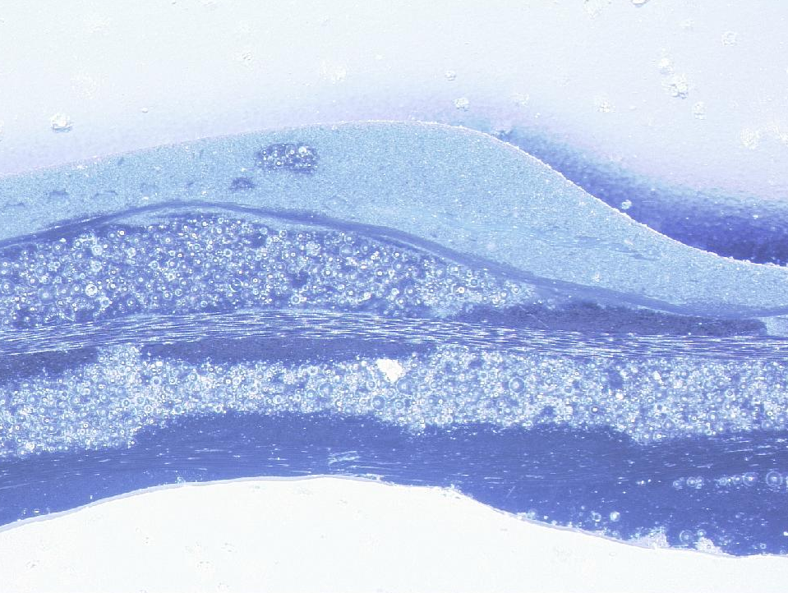
Fine polyester scrim starts to migrate from the surface
2μm
Fine glass scrim
Carbon fibre
Syntatic resin
Fine glass scrim
Syntatic resin bleed
Figure 3.39 – Optical image of the area perpendicular to the defect present around the badge detail (20x magnification)

According to Girard-Reydet et al. and Barral et al. [79,83], epoxy resins are very brittle due to high cross-linking density. This occurs when the resins cure, due to this brittle effect and the high concentration of resin in one area (higher than the nominal amount) the crack may have formed, as there was no fibre there to provide a small increment of flexibility within the laminate at this point. Additionally, in areas with a high concentration of resin it is common to have voids. Figure 3.40 is a more detailed image of the badge where it forms the “point” on the upper edge of the badge.

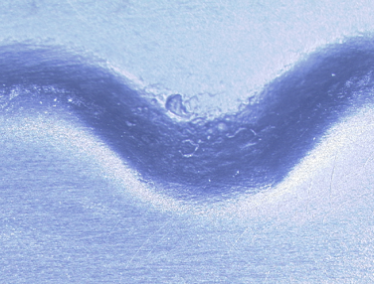
10mm
Figure 3.40 – Porosity on the surface at the perimeter of the badge (8x optical magnification)

From the previous section (Section 3.8.2 Worm Tracks), it has been found that porosity under the surface in an agglomeration, causes the Class A surface to break down. This defect occurred at areas of curvature in the bonnets. In these areas it is significantly important that there are no anomalies. This is due to the fact that it is very difficult to repair the anomalies with polyester filler prior to the paint process (Appendix 5.25) as the curvature is difficult to rebuild. This area was sectioned (as indicated in Figure 3.40) and the surrounding area under the defects studied. Figure 3.41 shows the findings.

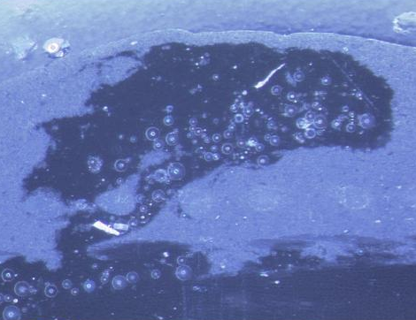
Fine polyester scrim is underneath this pocket of resin that has seeped through from subsequent layers
2μm
Glass fibre
Carbon fibre
Surface
Figure 3.41 – Section perpendicular to porosity at badge detail in the bonnet (57x optical magnification)

In Figure 3.41 it can be shown that the fine glass scrim has migrated below its intended location of just under the Class A surface. It can be seen that there has been a resin bleed from the subsequent layers under the surface film. The effect of this resin seeping through is clear, directly above it on the Class A surface there are clear abnormalities as the Class A surface curves downwards into the badge detail. The missing fine polyester scrim coupled with the resin seeping from subsequent layers results in a very poor quality of surface. The resin has seeped through a glass fibre and carbon fibre layer of fabric and is uncommon and has not been seen in the flat areas of the bonnet that have been studied, however, it has been observed at the edge of the bonnet but has not caused surface anomalies as the fine polyester scrim has been in the correct location – just under the Class A surface. This indicates that with the curvature of the badge detail and the vents, the fabrics have to follow the geometry on the tool surface, with this change in direction the fabrics are stretched so much so the tows in the weave of the fabrics are spread allowing a path for the resin to flow through. Once into the surface layer in this case, they have passed through to the fine polyester scrim to directly under the Class A surface causing anomalies. This indicates that the fine polyester scrim is a critical component within the CBS 95 for achieving the Class A surface quality that is desired.

3.8.4 Teddy Bears ears

The teddy bears ears have only been present around the top of the vents on bonnet number 1. An image that shows the area where the distortion has been witnessed is in Figure 3.42. At first stage analysis it was thought that this was due to de-moulding the part too soon at about 50°C component temperature. If the component is removed from the mould and it is above its glass transition temperature (Tg) the component cannot support its own weight and the geometric shape of the part will deform. This cannot be recovered on the Class A surface of the component once this deformation has occurred. This was tested on bonnet 2 when it was removed from the mould, the part was left in the tool until it had returned to room temperature (approximately 25°C), however, there was still evidence of the teddy bears ears in the same region of the bonnet.

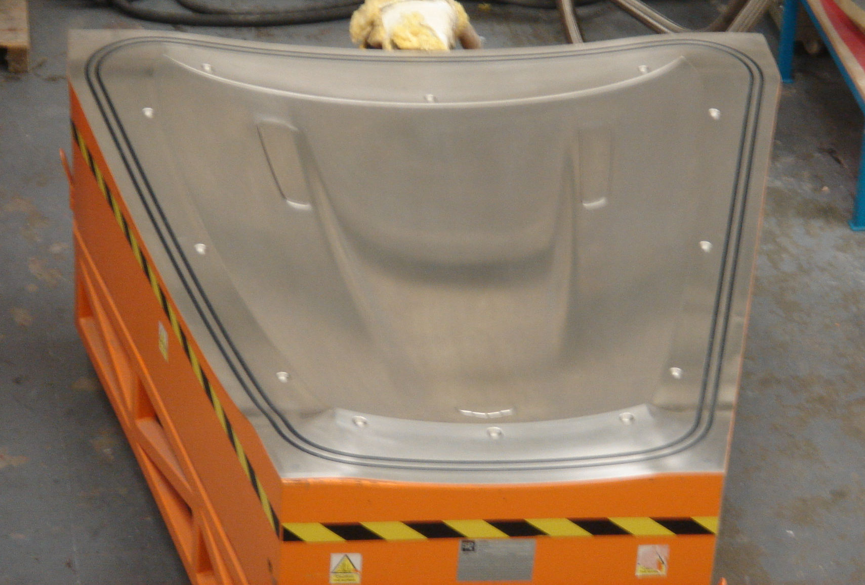
Figure 3.42 – DB9 Nickel Shell Tool showing areas of deformation that evident on bonnet 1

The cause of the deformation around the vents was investigated. There are many geometric changes in the curvature in this area of the tool. Additionally, there is also a kit join (red dashed line) as indicated in Figure 3.43 at this point in the bonnet. Also shown in Figure 3.42 is the double curvature (light and dark blue arrows) that the laminate has to take the form of. Figure 3.43 is of the right-hand side of the bonnet as you look at the tool, the witnessing, kit joins and curvature are all symmetrical on the tool.

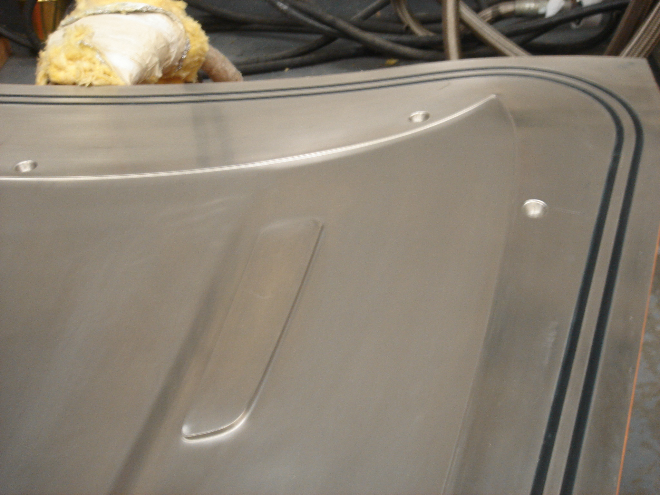
Figure 3.43 – Right-hand side of DB9 tool focused in the vent area

The method of manufacture that is used is vacuum bagging (Section 3.7.1.2 Lay-up for more information). Here the laminate is forced by the pressure of the vacuum to form the shape of the mould it has been laid upon. Therefore, the laminate is forced to form this desired shape. However, in this particular area where the shape is relatively simple the desired curvature is somewhat difficult, hence the number of bends the fabric has to follow. It is well reported that carbon fibre epoxy laminates contain residual stresses after component fabrication [103]. However, CBS 95 contains more than one type of fabric, there are three different types of fabric in the construction: carbon, glass and polyester of different weights.

In this area of the tool there is a double curvature (Figure 3.43), as mentioned previously. This has to be taken into account when designing the assembly of the kit. The double curvature in a design is also linked with the use of long tows. Obviously the shorter the tow length the section of fabric is more drapable. If there is a long tow length, there will be a scale up effect of the resin expansion and contraction relationship with the fibres, due to the difference in coefficient thermal expansion. Therefore, if you have a shorter tow length, there will be less distortion at the interface of the two sections of ‘kit’ where they meet over the top of the vent (Figure 3.43). Figure 3.44 shows the vent on the DB9 bonnet tool and there are superimposed horizontal lines representing the 0° carbon fibre and its journey in the vent section. When there are acute angles or curvatures to conform to in a design, each tow from where the curvature starts to its peak will be taughter than the last, therefore this is an example of the beginnings of internal stresses within the laminate. In Figure 3.44 it shows the curvature around the vent – peaking at the top edge of the vent.

This tow will have to travel an increment further than the previous tow due to the curvature leading up to the vent geometry
Figure 3.44 – Example of a 0° carbon fibre tow going a slightly further distance than the previous tow

With many engineering problems there are areas of negotiation, if the tow length is shortened there will be may more sections of the kit than the existing three, this in turn will extend the lay-up time of the component, however the teddy bears ears could be less visible.

In Figure 3.43 it showed the kit join above the vent. Kit joins have to be thought about carefully as there can be problems when a 0/90° fibre orientation section of the kit meeting a ± 45° orientation. This can occur due to geometric features within the component, which can induce a fabric orientation change, this can consequently cause significant problems. For example, when two templates join, each having covered separate parts of the component, and may be at a different orientation, the result can be severe witnessing on the Class A surface if these two sections come together at that point. The cause of the severe witnessing at a joint as described above is due to the difference in resin volume fraction. With the different orientations of a fabric there are also different volume fractions of resin, therefore the witnessing is essentially the resultant of different thicknesses of the component within this localised area.

It was noticed as the test programme progressed that there was a level of severity with the teddy bears ears. To isolate the difference the data that had been collected for each bonnet that had been manufactured was analysed. The data collected included information regarding the materials used, method of lay-up, consumables used and the cure cycle (Table 3.3). It was evident that the level of severity depended on the consumables used to vacuum bag the bonnet, specifically the type of vacuum bag that was used. There are two different types that are used at Gurit (UK); these are IPPLON® KM1300 and WRIGHTLON® 5400 (Table 3.3).

When the WRIGHTLON® 5400 bag is used at room temperature (i.e. lay-up of the bonnet) it is supple. This is very important when working the vacuum bag into the geometric features on the component as to avoid fibre bridging, which from section 3.8.3 Fibre bridging it has shown that this can cause porosity and surface abnormalities. However, as the cure cycle begins and the temperature increases the vacuum bag dries out, as it is hydroscopic. This causes the vacuum bag to shrink unevenly; if there is not sufficient bag around the geometric features it can lead to fibre bridging and uneven pressure on the Class B side of the component. As a direct cause of this there will be inconsistent resin volume fraction across the flat areas. If this does occur the shrinkage of the component during the cool cycle will be uneven too. This will then encourage buckling in the surface of the bonnet (Figure 3.45) in the areas weakened already by high internal residual stresses. This could be monitored by sectioning and quantifying the thickness over the bonnet in coordinated areas and plotting the distribution. This would achieve a thickness profile across the bonnet.

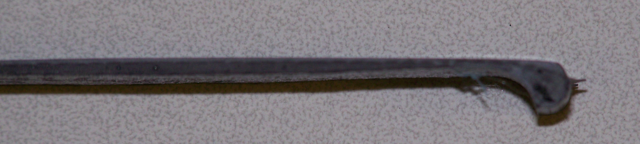
Thickness decrease of CBS 95 near vents
Figure 3.45 – Picture taken perpendicular to the Class A surface showing the thickness change near the vent detail.

3.8.5 Print through

Print through or fibre strike through as it is also known, was only evident on one bonnet that was manufactured during this test programme. This was noticed once it had progressed through the full paint process (Appendix 5.25). It was also only concentrated in a small area adjacent to the right-hand vent (see Figure 3.46).

Figure 3.46 – Area of Print through

The print through was analysed using the Proscan surface profilometer, this was to evaluate the depth of this surface defect. The CBS 95 is designed so that the surface film (SF 95) acts as a protective shield to prevent the visibility of fibre print through from the underlying carbon layer. Figure 3.47 shows the Proscan image that was taken from the area witnessing the print through.

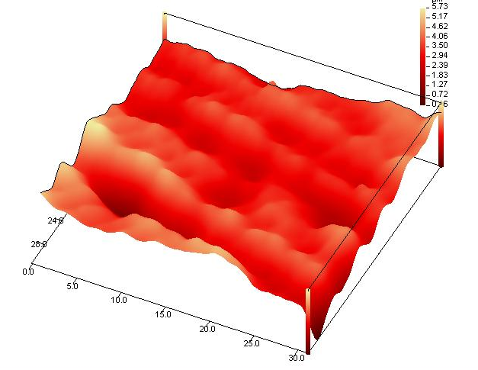
Figure 3.47 – Fibre print through Proscan image
The Proscan image measured the print through on the painted surface to be at an average depth of 3.2μm. Print through has been researched significantly and is influenced by volumetric changes in the matrix due to polymerisation shrinkage and thermal expansion of the matrix (Section 3.3.2). There is a difference between the localised resin rich regions around overlaying tows, these cause a regular surface pattern relating to the fabric architecture (Figure 3.5).

As this surface anomaly had only been witnessed just the once, the cause of the print through was of high concern. All of these initial bonnets (1-10) were taken through the full paint process and the print through only appeared in bonnet number 1. The print through forms due to the shrinkage of the resin around the fabric (in this case the carbon fibre). To evaluate the state of the resin in the bonnet a Dynamic Mechanical Analysis (DMA) test was performed on a section of the bonnet from the area with the print through. In order to achieve an accurate result from the laminate the paint and primer layers were removed carefully from the surface of the sections tested. The results are shown in Figure 3.48.

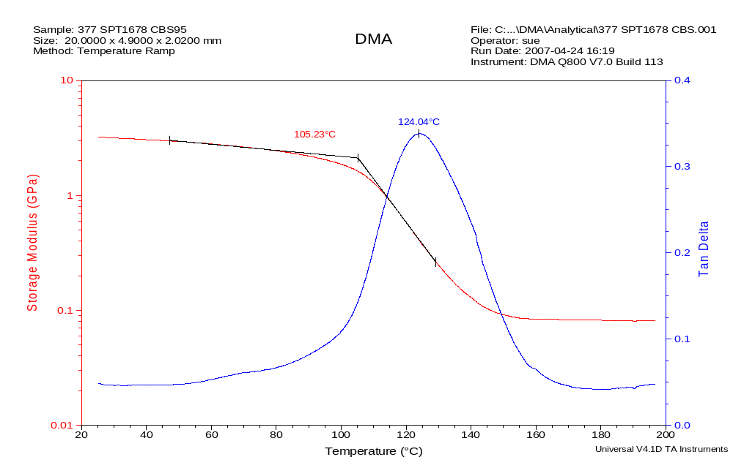
Figure 3.48 – DMA analysis of the area with print through

Figure 3.48 shows that the Tg1 from the DMA analysis is 105.23°C, from previous research calculating the Tg for CBS 95 (Appendix 5.26), this indicates that the resin has not been fully cured, hence this area of the tool has not been at 130°C for 20 minutes as required by the given cure cycle for this resin. To confirm that the resin from the CBS 95 had not been fully cured a section from the area with the print through was post cured to 130°C for one hour and then retested in the DMA. The results are shown in Figure 3.49.

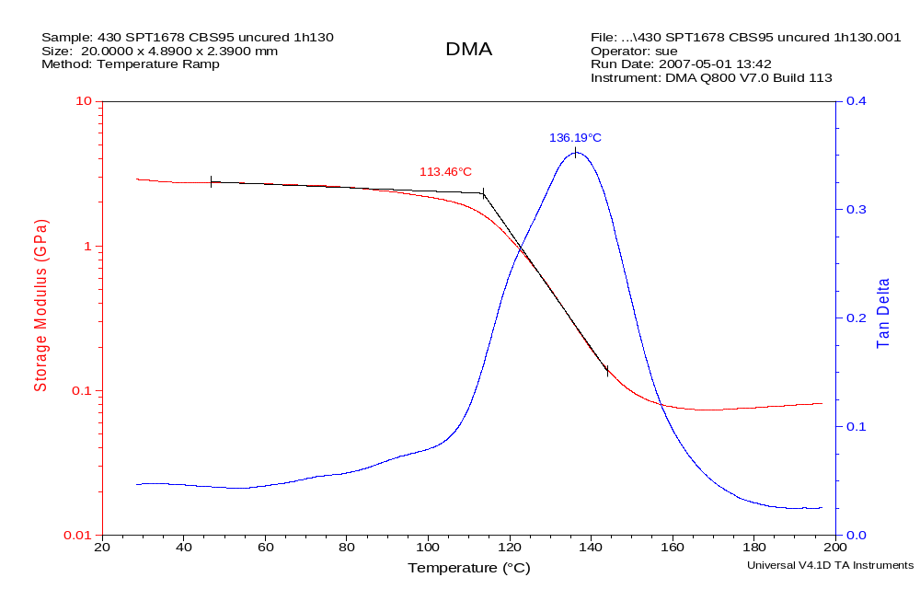
Figure 3.49 – DMA results of the post cured section from the print through area

After the one-hour post cure the Tg1 that was attained after the second DMA test was 113.46°C. This confirms that the area with print through is uncured resin. A typical Tg1 that is expected from fully cured CBS 95 is 115°C (from previous work Appendix 5.26), hence this area measured initially 10°C under the desired Tg1, and therefore this verifies that the resin is uncured in this area. This is discussed in detail in section 3.3.2 in the literature review.

The bonnet that the print through was evident was one of the first bonnets to be produced. From Figure 3.42 it can be seen that the tool is very large (1.5m x 2.0m) and the mass of thermal insulator on the back of the tool behind the nickel shell is significant. It was thought that this thermal mass was inhibiting areas of the tool from heating rapidly therefore causing thermal lagging in this area of the tool. The tool was initially thermally mapped using a thermal digital camera to give a general overview of the hot and cold spots on the tool. Figure 3.50 shows the thermal image take from the area in question where the print through originated.

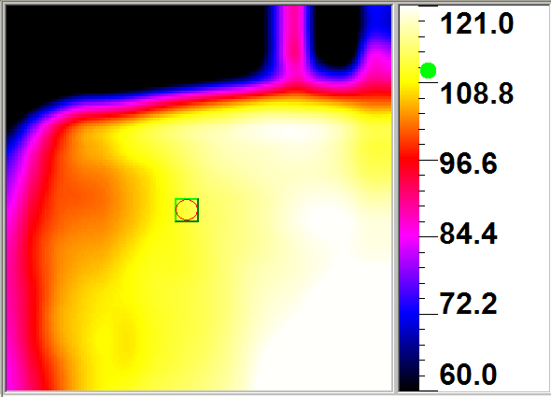
Figure 3.50 – Thermal image of area where print through witnessed

A full thermal image of the tool could not be captured, as the surface area of the tool is larger than the field of view of the thermal camera. To capture the hot and cold spots with the thermal camera the optimum time is while the tool is heating to 130°C, not once it has reached 130°C. The reason behind this is that once the tool has reached 130°C the tool then stabilises and if left for suitable time the whole of the surface area will have reached equilibrium at 130°C, thus masking some of the hot and cold spots on the surface of the tool. From Figure 3.50 it can be seen that this is a cold spot on the tool surface as it is lagging behind by 25°C, which is a significant temperature difference considering there is only 20 minutes given for the whole component to fully cure at 130°C. The thermal camera can locate the areas that heat the fastest or slowest but it cannot quantify how long they take to reach the 130°C optimum for cure. Therefore, the tool was thermally mapped again using thermocouples distributed over the tool surface. One of the thermocouples was placed in the cold spot that caused the print through. Figure 3.51 shows the location of the thermocouples on the tool.

Right
Left
Figure 3.51 – Location of the thermocouples on the bonnet tool

Figure 3.52 shows the results from the thermocouples. The cure cycle used was the cure cycle that had been applied to all the bonnets so far, shown in Figure 3.16. To ensure that the thermal mapping was representative of the manufacture of a bonnet, the thermocouples were placed in between the surface film and the car body sheet.
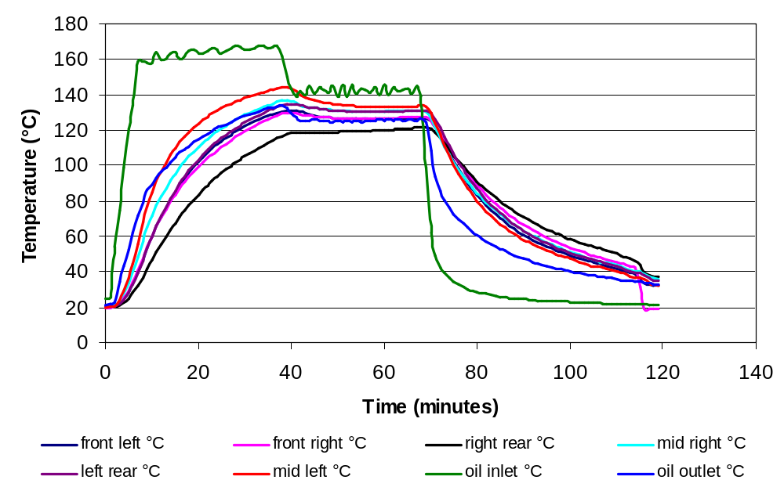Figure 3.52 – Thermocouple monitored cure cycle
It can be seen clearly that the thermocouple that was placed in the area where the print through was identified. It can be seen that this area of the tool does not reach 130°C, as to be fully cured at 120°C it has to be given one hour. Using Figure 3.52, it can be calculated the time extension required and oil temperature increase to ensure that this cold spot is at 130°C for 20 minutes, therefore confirming that the resin will be fully cured. The locations of the other thermocouples show that they are reaching 130°C for the desired 20 minutes. The cure programme was adjusted on the tool heater to allow for the additional time to ensure that the cold spot reaches 130°C for 20 minutes. The thermocouple mapping was repeated by placing the thermocouples in the same locations as shown in Figure 3.51. Figure 3.53 shows the revised cure cycle with a second thermocouple mapping of the tool.
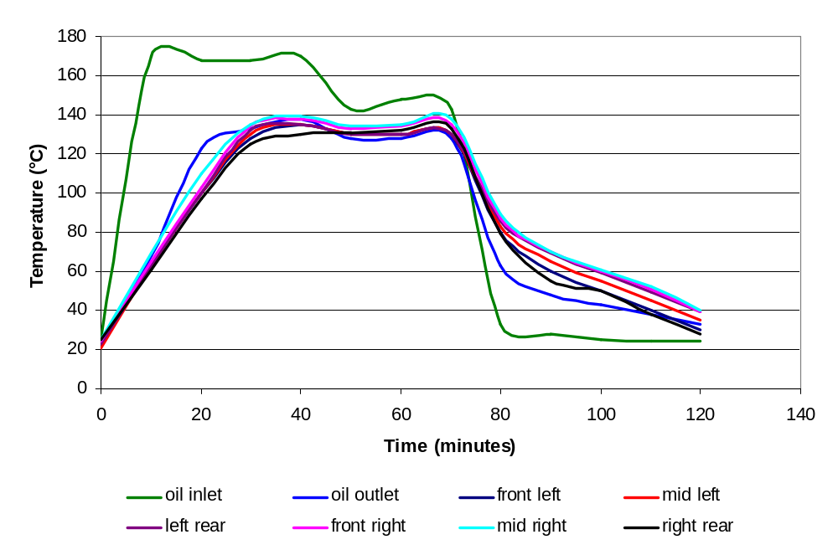
Figure 3.53 – Amended thermocouple monitored cure cycle

It can be seen from Figure 3.53 that the area in question, is now at 130°C for 20 minutes. The first bonnet that was manufactured using this modified cure cycle proved that the problem had been addressed, after the paint process there was no evidence of print through in this area of the bonnet. Unfortunately, there is no evidence here to prove this.

The initial cure cycle that was formulated for this resin system was based on a chemical analysis of the resin in the laboratory. However, the curing of a component in the oven results in a different heat pattern compared to heating only the surface of the tool.

