A 3D Design Performance Matrix for Product Design and Development

Yuanyuan Yin, Shengfeng Qin, Ray Holland
School of Engineering and Design, Brunel University, Middlesex, Uxbridge UB8 3PH UK

Abstract
This paper presents a novel 3-dimensional design performance matrix (model) for a web-based product design and development. The first dimension highlights five performance indicators: efficiency, effectiveness, collaboration, management skills and innovation, these are most influenced by role-based performance measurement criteria in the second dimension. The third dimension takes product design and development process (time) into account. This 3D model allows all involved design participants to measure work performance at any time during the product development process. In order to develop this model, the role-based task analysis and industrial survey methods were utilised in couple with the Universal Modelling Language (UML). Three groups of role-based product design and development performance measurement criteria were identified for measuring the top managers, middle managers and individual designers in a design project team. A 3-dimensional performance measurement method was explored to calculate final performance scores from the performance measurement matrix. Proposed model has been evaluated for implementing in a web-based application for measuring design performance of different role-players throughout the product design and development process. This model can support distributed design and manufacturing business in performance management.
Key Words: performance management, role-based task analysis, 3D performance measurement modelling, distributed design, design management

1. Introduction
New product design and development is the life-blood of high-tech manufacturing. In an environment characterized by increasing product design quality, shrinking product life cycles, intense price pressure, rapid technological change, and market turbulence, development of a steady stream of new products is the only way to ensure survival and success. Design is recognized as an important factor in new product development, and it has a considerable influence on the final business outcome and the investment-return rate (IRR). One of the key issues at the forefront of any chief executive’s mind has been the question ‘how to create and sustain competitive advantage on a global scale through design’. There is a growing investment in and awareness of the importance of New Product Development (NPD), but many companies still struggle to determine how well their product design and implementation is doing.

Research about performance measurement (PM) has been developed from several viewpoints, such as time (Hultink et al., 1995), strategy (Loch et al., 2001), management techniques (Keys, 1991), product launch (Bendedetto, 1999), project-level management, and organization (Griffin 1993, 1996). Primarily, problems in measuring product design performance arise because: a) project effort levels are not directly observable; b) the consequences of actions are not directly observable; c) there is high level of uncertainty in the whole process; and d) different design projects have various goals, so success criteria are varied (Feltham & Xie 1994, Craig & Hart, 1993). Griffin (1996) concluded that companies do not measure development success and failure mainly because they have no such a system in place, and company culture does not support measuring. Facing a huge number of performance measure subsets for PM, it is difficult for users to select an appropriate measure matrix for their business. The question remains as to how these various measures are related to each other and to business success (Mallick & Schroeder, 2005).

Although, many NPD design performance criteria were found in the existing research, there are still some gaps in this research. Firstly, most of the existing PM criteria are rooted in data which can only be obtained after the product has been launched, such as market share and customer satisfactions. Thus, PM can only be operated after the product launch. Companies do not have the opportunity to obtain product design performance feedback while running a project to improve their commercial benefits or investment-return rate. A company can learn from the failed product to develop a new product in the future, but this kind of PM does not make any sense for the failed product itself, as the company will have already lost investment. Therefore, how to implement PM during the project process becomes a key factor to support product design success. Secondly, almost none of the research presented a practical system which could be used by project managers to measure their product design and development performance. Thirdly, it is not clear how to operate a PM system for a collaborative design hierarchy.

Thus, this study focused on two key questions:
- Which criteria can be used to measure product design performance during the project development process?
- How can the proposed system be operated in practice for collaborative product design?

In order to answer these two key questions, role-based task analysis and industrial survey have been utilized in this research coupled with universal modelling language. Resultant 3D performance measurement matrix allows all involved design participants to evaluate their role-based performance during the product design and development process. It is also easy to be implemented in a web-based application to support collaborative design and digital manufacturing activities. In this paper the authors describe (1) the research methodologies in Section 2, and (2) a preliminary study in Section 3, (3) a 3D design performance model and measurement method in Section 4, (4) flexibility of implementation of proposed model in Section 5, and (5) conclusion in the last section.

2. Research Methodologies
In order to identify fundamental product design and development PM criteria, role-based task analysis, a literature review and industrial surveys were employed. The literature review was conducted from journal papers, conference proceedings, books, magazines and company reports. The objectives of the literature review were to study the existing design PM criteria from academic research, and investigate how PM has been implemented in the last decade. The aim of the industrial survey and questionnaires was to find out a) how companies implement design PM, b) investigate current problems, c) create design PM matrices, d) evaluate research outcome. The authors interviewed five relevant managers recommended by the top managers in five different companies: three in China and two in the UK.

Role-based task analysis was conducted to differentiate team members’ responsibilities and duties. Design PM criteria were created according to different design activities of different team members.
A 3-Dimensional method of measurement was explored to calculate final scores of project design performance, based on design activities, design PM criteria, and changing criteria priorities during the product design and development process.

The authors adopted Universal Modelling Language (UML) to set up a structure for the conceptual framework. UML is the de-facto standard for the analysis and design of software. One of the most important components of UML is class diagrams, which model the information in the domain of interest in terms of objects organized in classes and the relationships between them (Fowler & Scott, 1997). It is a general-purpose visual modelling language which can specify, visualize, and document the components of a software system (Shin & Ahn, 2000). Based on UML, the proposed system hierarchy comprises layers: top management, middle management and the bottom level staff.

Finally, web-based prototype software and UML role-based access control were proposed to solve role-based task performance measurement and management for collaborative product design and development. In UML role-based access control, permissions are associated with roles, and users are made members of appropriate roles, thereby acquiring the roles' permissions (Shin & Ahn, 2000). Web-based prototype software can allow every design participant access to the system at any time and anywhere.

3. Preliminary study
3.1 Literature review
In order to find out which criteria can be selected and examined during product design and development process, the authors reviewed PM principles and key success factors in NPD. This research reviewed investigations of NPD PM, product design success/failure factors and the concept of a process in NPD.

PM has been much discussed in both academic and practitioner literature. Research has discussed PM from different viewpoints, to indicate how to implement PM systems. A meta-analysis of determinants of new product development success identified 47 published research works that used a single measure of success or failure for product development (Montoya-Weiss and Calantone, 1994). Brown (1995) emphasized the need for understanding the relationships between various matrices used for measuring product development performance. Salter (2003) indicated that PM is based on the financial performance of a project rather than on other important objectives. Some papers explored the linkages between key features of the NPD process and NPD performance and suggested ways of designing the process to improve performance (Bhuiyan & Gerwin & Thomson, 2004). Manufacturing PM has been discussed from academic and practical perspectives; Babu’s (2003) PM research focused on manufacturing organizations and highlighted inter alia lack of strategic focus, not being externally aware, and encouragement of short-termism, factors in which most systems are deficient. An application of an approach to the measurement and optimisation of total productivity within a manufacturing plant case study demonstrated how a relationship can be formed between plant inputs and output and how it can be used to maximise the total output/input productivity ratio (Rathore et al, 2003). Pun et al explored PM from a self-assessment aspect, and presented eight evaluation criteria and 21 sub-criteria for manufactures to evaluate their corporate-wide learning performance (Pun, K.F. et al, 2003).

Hart (2003) presented evaluation criteria based on NPD development processes. In an extensive review of the NPD literature, Cooper's 'stage-gate' approach (1994) has been used to provide a structure for the decision making elements in NPD and to ensure that active decisions are taken when resource commitment decisions must be made (Bessant & Francis, 1997). Other research investigating what happens during the NPD process and how it influences project outcomes was conducted by Cooper (1986, 1995, and 2003) and Calantone & Benedetto (1988). Different sections in the NPD process have different characteristics, and the PM criteria are different too. Most of the existing PM criteria which can be used to measure the NPD process are rooted in the data which can only be obtained after the product has been launched. Thus PM can only be operated after the product launch. Companies have no opportunity to gain commercial benefits or investment-return rate. Therefore, how to implement PM during the project process becomes a key factor to support success.

PM becomes significantly more accurate and complex if researchers decide to use multiple measures of performance. Based on the literature review, the authors analyzed existing PM criteria according to the product development process, and concluded that design performance can be measured in conformity to five multiple measurement items during the product design process. From marketing research/idea screening, stage staff performance can be measured based on efficiency, effectiveness, collaboration and management skill, and innovation performance can be measured later following the first user test or technology test in the early stage of the project process.

3.2 Role-based task analysis
Most of the existing PM criteria are rooted in data which can only be obtained after the product has been launched, such as market share, customer satisfactions, and so on. These PM criteria cannot be operated during the product design and development process; therefore, the authors had to find another way to measure product design performance.

Harsh competition has led to increased emphasis on creativity and innovation as a crucial dimension in business. In response, it is suggested that designers are undertaking a leadership role in the product development process (Von Stamm, 2003). Scholars suggest design responsibilities should expand to roles that support the whole project development effort. Consequently, project design performance involves every team member’s design contribution.

Based on the literature review and the industrial surveys, project performance can be divided into parts classified by different functions such as design, engineering, and marketing. Each function is relevant to the people who work with it. In a cross-functional team, each member has a different duty to contribute to the whole project, and he/she needs to collaborate with other team members. Therefore, every team member’s performance influences the result, which means that the performance of members should be measured. Understanding each member’s work responsibility and his/her performance becomes a key to measuring performance appropriately. If every team member has design performance, the final project performance will be successful. However, any team member’s small mistake may overthrow the whole project. Thus, the design performance of project can be viewed as an aggregate of teamwork design performance. Organizational process factors in NPD are associated with achievement of operational outcome targets for product quality, unit cost, and time-to-market (Tatikonda & Montoya-Weisis, 2001). From an organizational point of view, the authors considered that a new product design and development team should have three levels: top management, middle management and bottom staff (Figure 1). Every product design project should have an investment manager or a CEO as the top manager to control and take overall responsibility. Then, there should be several middle layer managers to administer different sectors in the product design and development. Depending on the size and complexity of the project, the number in the middle management layer can vary from zero to several. Finally, under each middle layer manager there are some individual workers at the bottom. The bottom layer is composed of engineers, designers, marketing people, and sales staff and so on. Within this structure, all the involved design participants are included in the performance measurement and management system.
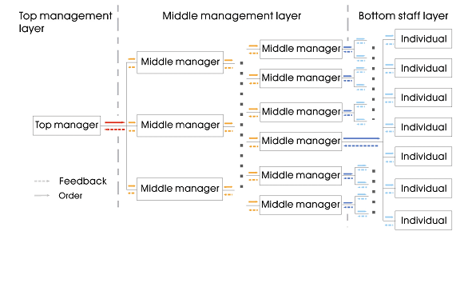
Figure 1: organization structure of product design team

3.3 How to measure staff performance?
Work performance of the middle manager is evaluated in four ways: comments from the high level manager, feedback from the lower level staff, comparison with the same level staff and performance management by themselves. (See figure 2)

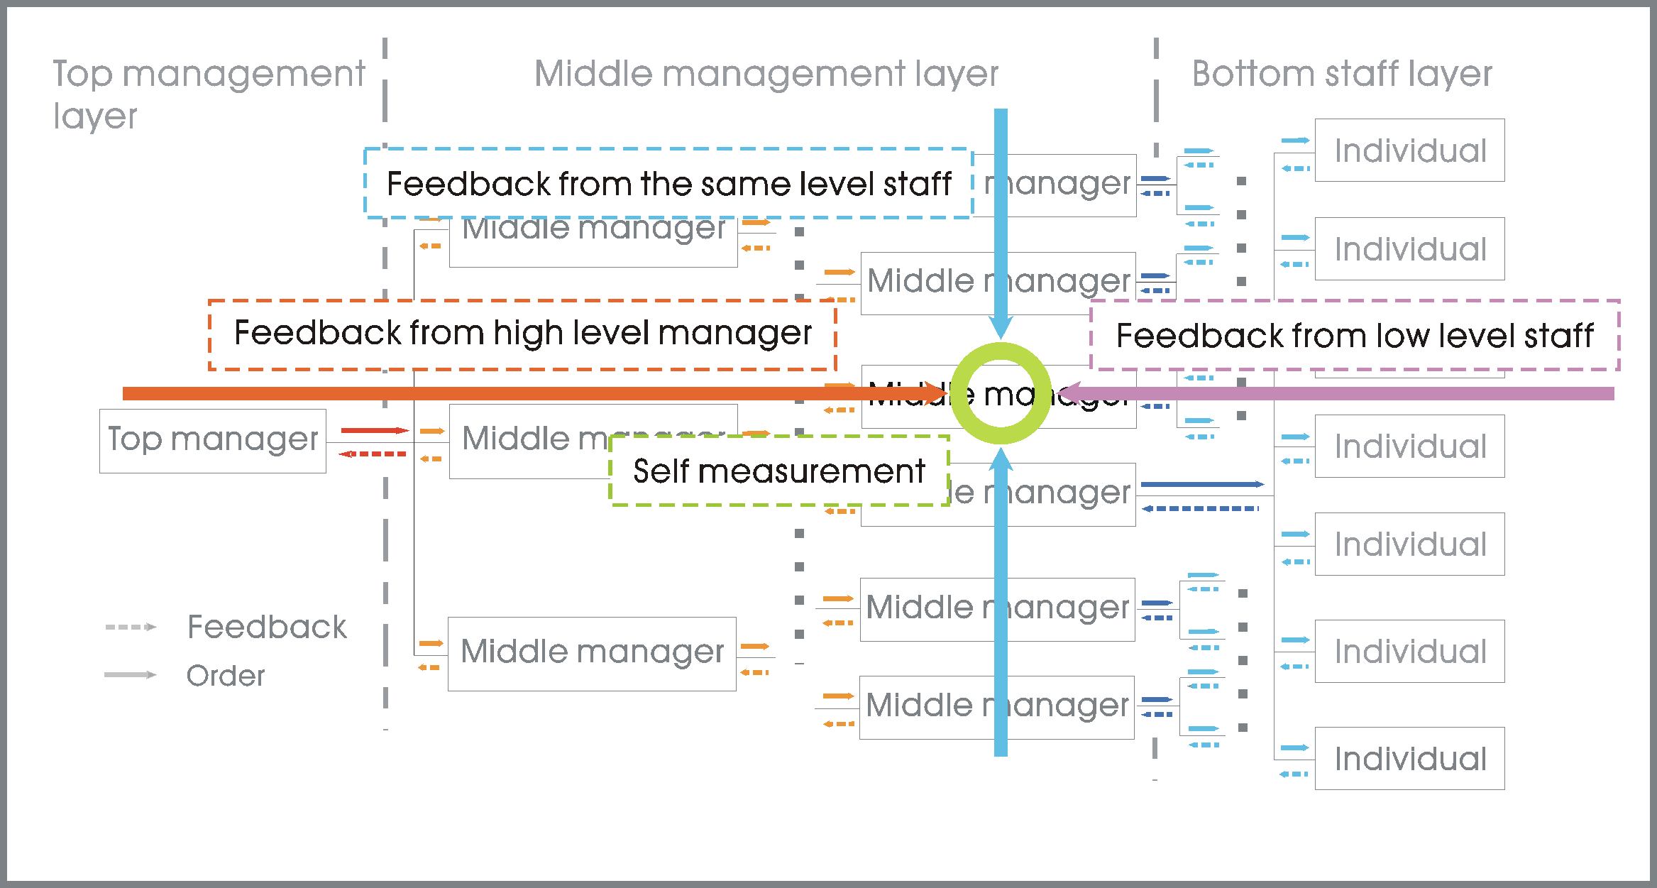
Figure2: Performance measurement for the middle layer manager

Three methods evaluate the bottom layer staff performance: comments from managers, comparison with the same level staff and PM by themselves (See figure 3). As for the middle manager, all the PM feedback is analyzed according to the PM criteria from the five design items.
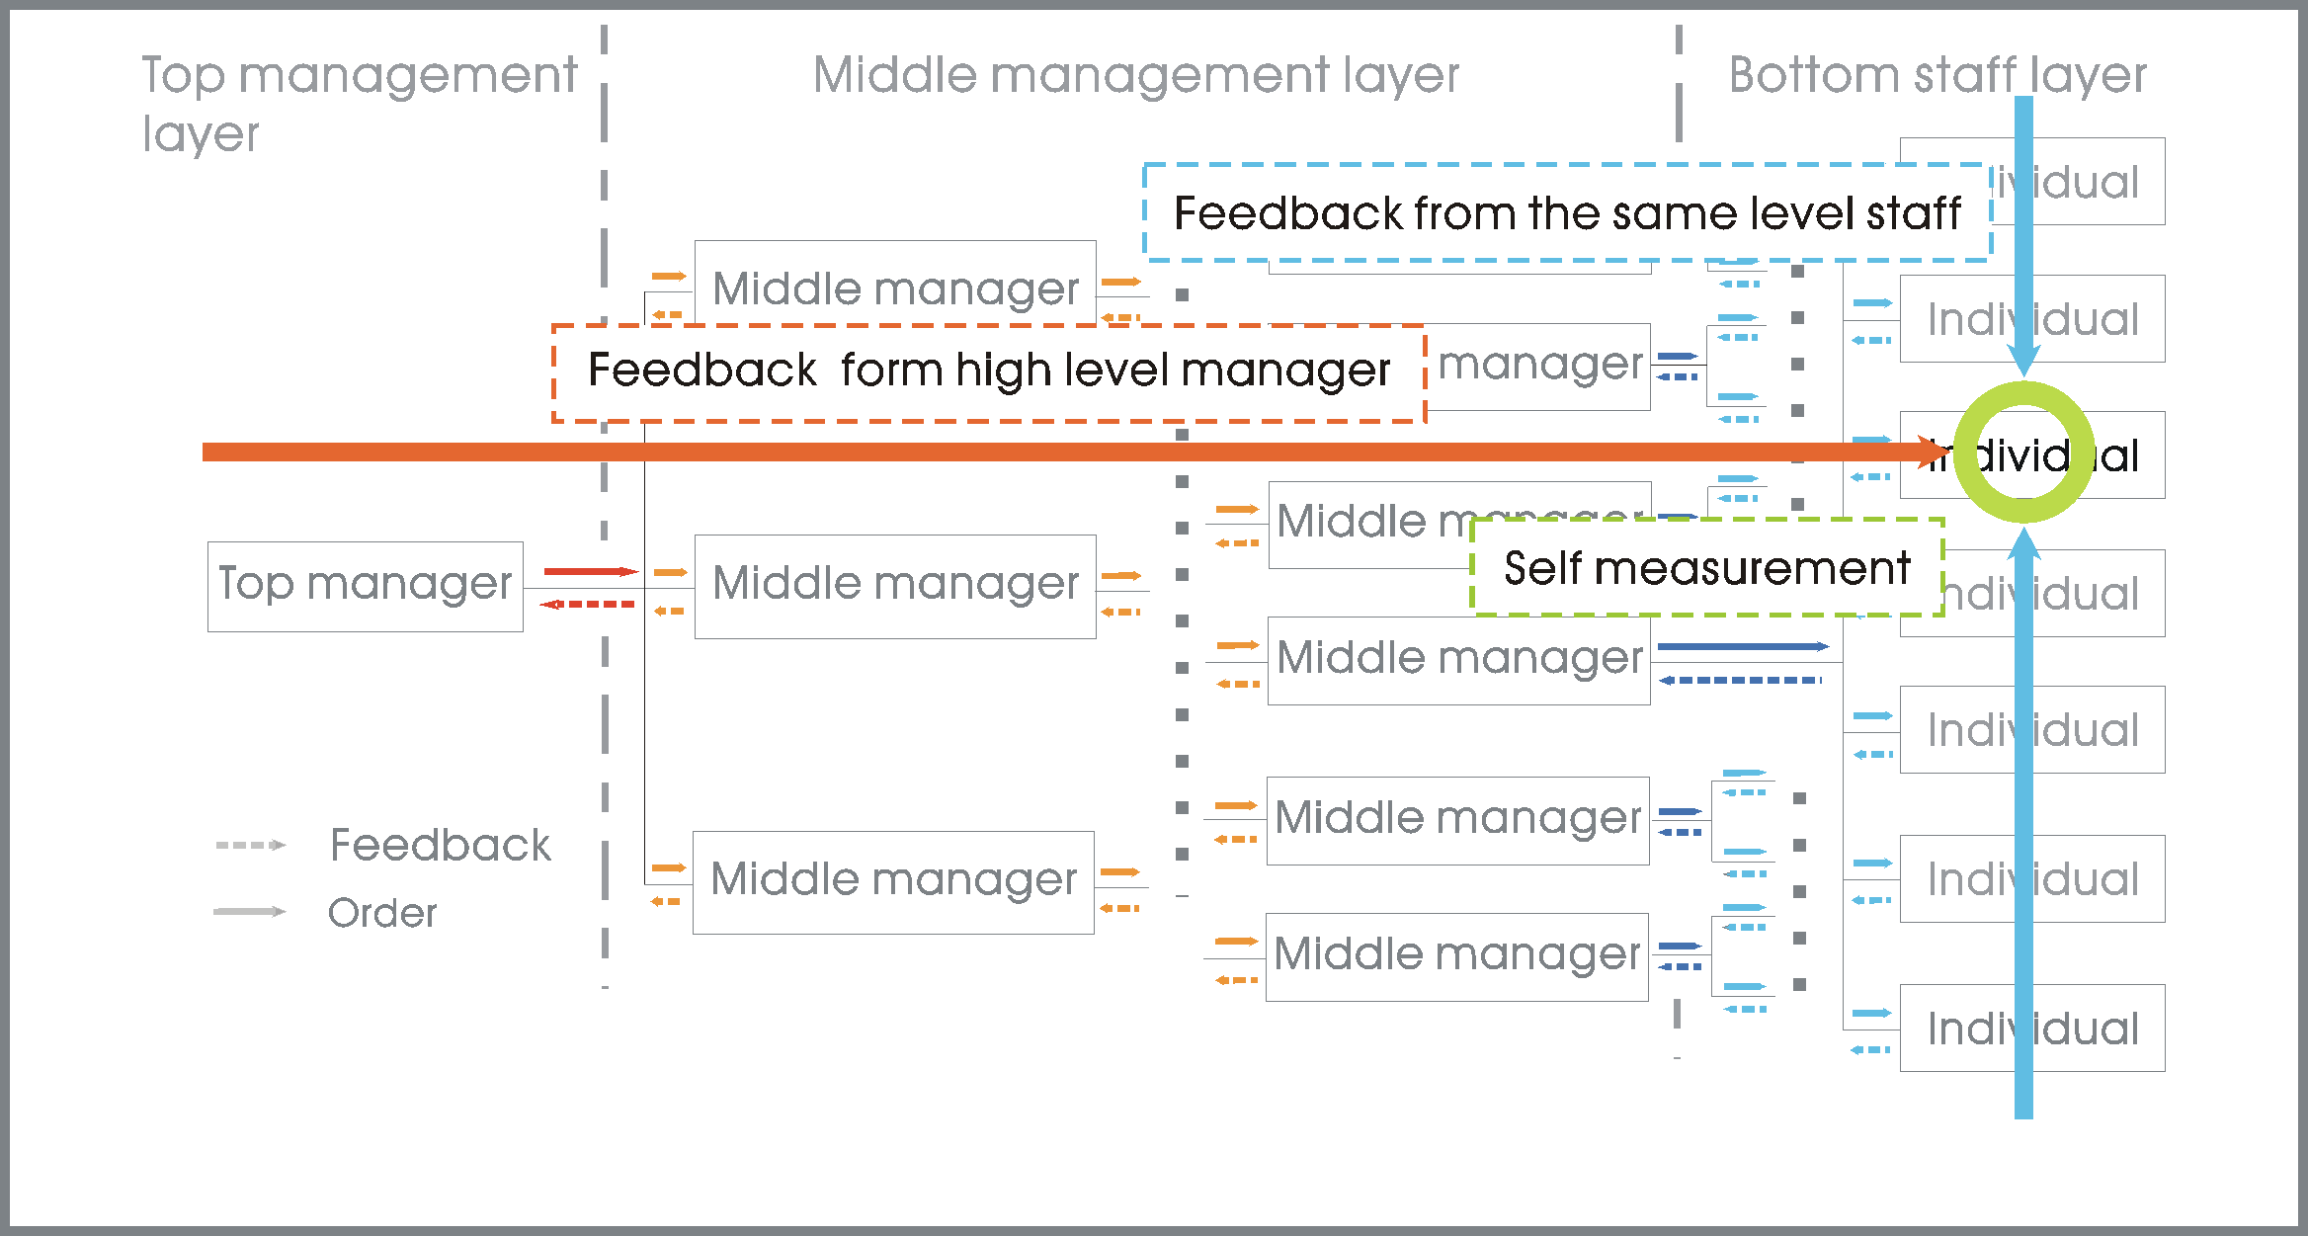
Figure3: Performance measurement for the bottom layer staff

3.4 How to measure total staff performance?
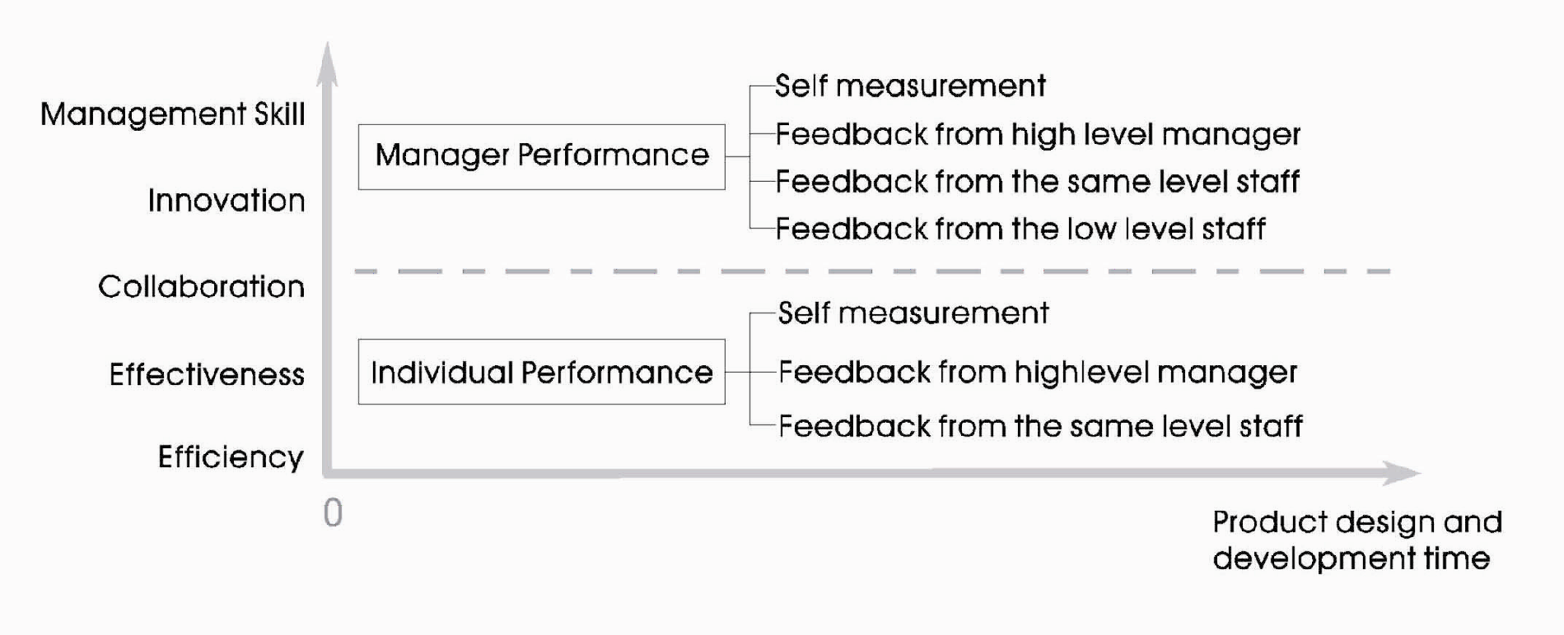
All the PM feedback includes self measurement, feedback from higher or lower level staff, and feedback from the same level staff analysed based on the PM criteria. Staff receive five marks for their work performance based on efficiency, effectiveness, collaboration, innovation, and management skill aspects. Then the total performance mark is calculated for the five items. For different product design projects, different design PM criteria may have different weightings. Thus, the system allows advanced users to set up measurement criteria with different weighting to match the specific product design and development. (Figure 4)
Figure 4: Design PM Method
Figure 4: Design PM Method

3.5 Design PM matrix
According to the model of the organization structure of a product design team, the authors conducted industrial interviews and questionnaire surveys in China and the UK to identify team member’s responsibilities and duties in different hierarchies. The 9 interviewees included product designers, design managers, product engineers and project managers. There were 74 responses to the questionnaire survey. The interviews and questionnaires distinguished and clarified different design PM matrices for different level staff, and sought the most frequently detailed PM criteria for each design PM item, and the system structure.

86% of the interviewees believed the proposed model was a reasonable and operable design performance measurement and management system which could be implemented in various industrial organizations. They suggested that the model should be further developed to include more details about the five PM items and make links between practice behaviours and PM criteria.

Based on the literature review, the authors drew out 42 design PM criteria and classified those criteria into the 5 design PM items to build up a generic design PM matrix. The Industrial survey asked interviewees to pick the top criteria from each item. The results of the questionnaire survey (Table 1,2,3,4,5,6,7) indicate the following: (1) from an efficiency point of view, more than half the people regard problem solving skills as the most important factor to measure staff work performance. The efficiency factors are: work planning skill, decision-making efficiency, ability to finish work on time, and ability to work under pressure; (2) from an effectiveness aspect, more than half the people think the ability to align objectives and action is important during the product design and development process. Similarly, for management skill and collaboration indicators, the ability to exchange information and role-taking are important. The authors describe innovation performance from three aspects: market, finance and product. From the results, it is clear that market potential, R&D budget and product design are the important elements for product design and development PM. The top five factors for each section can be identified in Table 1.

Table 1: Identified generic design PM matrix
Design Performance Measurement Matrix for normal staff
Efficiency | Problem solving skills, Work planning skills, Decision-making efficiency, Finishing work on time, Ability to work under pressure
Effectiveness | Align with objective and action, Rapid and rich feedback, Personally responsible, Managerial decisional errors, Social influences
Collaboration | Information exchange, Cross-functional collaboration, Communication environment, Group conformity, Information processing
Management Skill | Role-taking, Interpersonal control, Detecting and reducing the discrepancies, Openness, Department membership communication behaviour
Innovation | Market potential, Customer acceptance, R&D budget, IRR & ROI, Product design, Technical performance

Table 2: 42 Design PM criteria
Performance measurement matrix for middle normal staff
Problem solving | Objective and action alignment | Information exchange | Role-taking
Work planning | Rapid and rich feedback | Cross-functional collaboration | Interpersonal control
Decision-making efficiency | Personal responsibility | Communication environment | Detecting and reducing discrepancies
Finishing work on time | Managerial decisional errors | Group conformity | Openness
Ability to work undertake pressure | Social influences | Information processing | Department membership communication behaviour
Self-knowledge | Self- justification | Helping other staff | Managers' reputation
Personal motivation | Development cost reduction | Team-justification | Informal network position
Self-confidence | Testing concept technical feasibility | Communication network | Market potential
Information recalling | Shorting time from idea to commercialization | Time available to help other staff | Customer acceptance
Written communication | Social validation | Self-presentation | Customer satisfaction
Self-learning | Self-preferences | R&D budget | Customer evaluation
Time available to study | Normative influence | IRR & ROI | Product design
Concept to market | Met margin goals | Sales growth | Technical performance

Table 3: Result of identified efficiency and effectiveness PM criteria
Efficiency |  | Effectiveness
Problem solving | 62.7% | Objective and action alignment | 50.7%
Work planning | 49.2% | Rapid and rich feedback | 46.2%
Decision-making efficiency | 35.7% | Personal responsibility | 37.4%
Finishing work on time | 30.3% | Managerial decisional errors | 32.4%
Ability to work undertake pressure | 27.2% | Social influences | 29.9%
Self-knowledge | 22.2% | Self- justification | 25.6%
Personal motivation | 18.6% | Development cost reduction | 23.1%
Self-confidence | 15.1% | Testing concept technical feasibility | 18.6%
Information recalling | 13.5% | Shorting time from idea to commercialization | 16.4%
Written communication | 11.3% | Social validation | 13.8%
Self-learning | 4.5% | Self-preferences | 4.6%
Time available to study | 3.2% | Normative influence | 4.2%

Table 4: result of identified collaboration and management skill PM criteria
Collaboration |  | Management Skill
Information exchange | 59.1% | Role-taking | 58.8%
Cross-functional collaboration | 45.6% | Interpersonal control | 48.3%
Communication environment | 36.4% | Detecting and reducing discrepancies | 44.2%
Group conformity | 30.3% | Openness | 42.1%
Information processing | 28.6% | Department membership communication behaviour | 37.2%
Helping other staff | 25.1% | Managers' reputation | 28.5%
Team-justification | 23.3% | Informal network position | 25.4%
Communication network | 19.8%
Time available to help other staff | 13.4%
Self-presentation | 11.4%

Table 5: Result of identified innovation PM criteria
Innovation
Market |  | Financial |  | Product
Market potential | 70.3% | R&D budget | 76.5% | Product design | 58.2%
Customer acceptance | 64.2% | IRR & ROI | 58.4% | Technical performance | 55.8%
Customer satisfaction | 57.2% | Sales growth | 48.9% | Concept to market | 48.8%
Customer evaluation | 34.6% | Met margin goals | 32.5% | Time -based competition | 33.6%
Market share | 26.5% | Unit cost | 27.6% | Speed to market | 27.6%
Met market goal | 22.4% | Unit sales goals | 22.6% | Met quality guidelines | 24.2%
Market uncertainties | 7.8% | Profitability of a firm | 14.2% | Time to market | 20.1%

For manager level staff, their performance can be measured based on the generic design PM matrix, but as a leader or manager they also have some specific characteristics. Belbin (1993) highlighted plant, resource investigator, co-ordinator, monitor evaluator and so on to describe manager-roles contributions. Shead (2006) founded eight key factors and four different leadership roles which could be used together to measure leader’s or manager’s performance to improve team work effectiveness.

According to the literature review in leadership, team roles management, roles of personality in new product development team performance, and the industrial survey, the authors identified PM matrices for top level manager and middle level manager (Table 6, table 7).

Table 6: Design PM criteria for middle level manager
Performance measurement matrix for middle level manager
Communicate effectively between individuals, up and down the organizational hierarchy. | Be ethical and inquisitive
Develop and mentor staff | Current values and motivations
Manage conflict | Experience
Manage group dynamically | Field constraints
Monitor and evaluate team performance | Passionate
Create a generic/creative environment context | Role learning

Table 7: Design PM criteria for top level manager
Performance measurement matrix for project leader
Create a reasonable/ sensible/ logical infrastructure of the project team. | Be able to build high morale within team
Define complementary roles and responsibilities for each team member to covering all that are relevant to delivering the group's goal. | Be honest/ having integrity
Investigate resource ( resource investigator) | Desire to lead
Know the business area | Motivated
Make clearly defined goals | Self awareness
Make organizational priorities | Self-confidence

4. 3D design performance model and measurement methods
Based on secondary research, the authors found that the speed rate of investment increases during the product design and development process. Before manufacturing, the project team needs only general resources such as office facilities, and office stationeries. Manufacturing is the stage which needs the biggest investment for production facilities, labour, and materials. Therefore, it is very important to make sure design performance fully supports manufacturing.

4.1 3D performance model
A great deal of research about NPD process has been carried out, focused on different perspectives. Keinonen (2006) and his colleagues reviewed the conceptual design development process of products in industry. They indicated product design is customarily linked to manufacturing; products fulfill the needs of customers, and business is built on the exchange of products. They identified three generic design activities for conceptual design: background research, concept generation and concept evaluation. A generic product design and development process was explored as marketing, R&D, concept screening, detail design, user test, finalization design, and manufacturing (Keinonen et al 2006, Ulrich et al 2004, Baxter 2002, Cooper et al 1994).

Table 8: Product design and development process
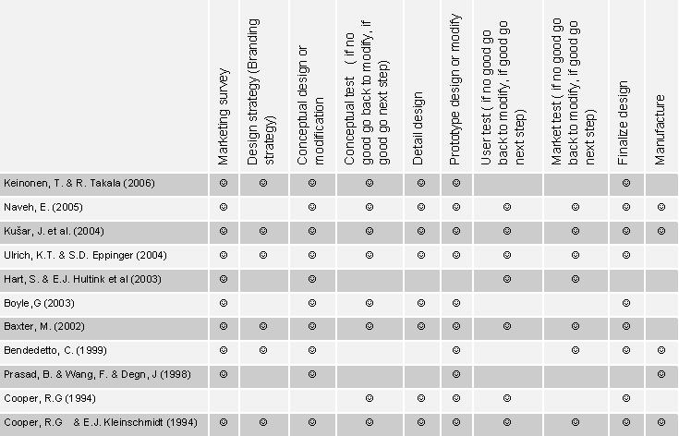

The authors compared different product design and development frameworks and synthesized the relevant research in order to build up an integrated product design and development process (Table 8). This comprehensive product design and development process can provide a clear understanding of all design activities which may be conducted in each section during the product design and development process.

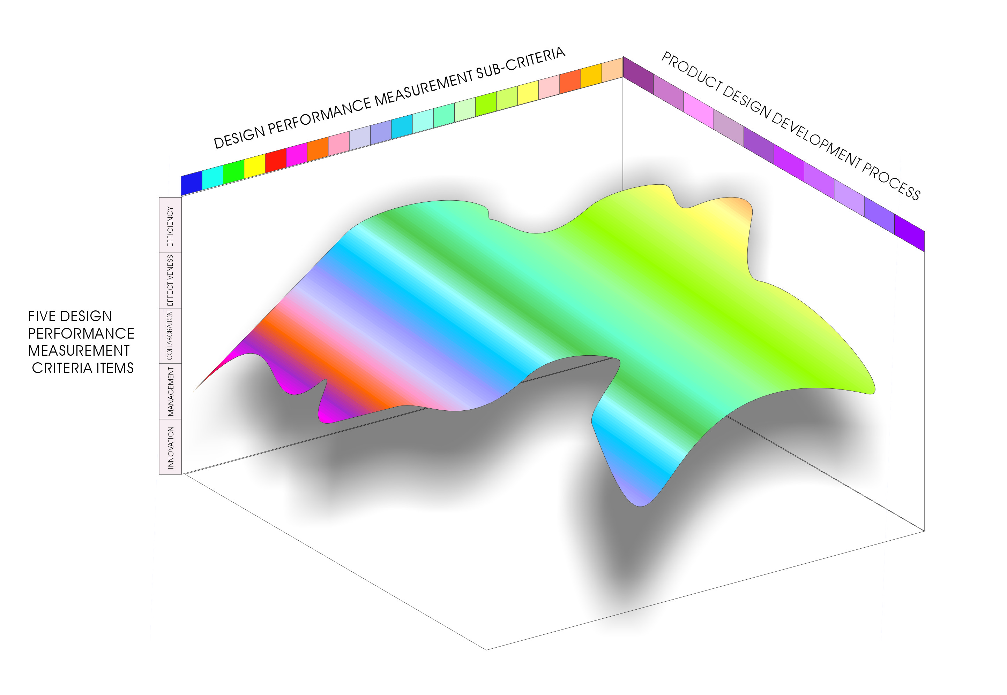
Some researchers have related the NPD process with PM research, as different sections in the NPD process have different characteristics and different combinations of technical and commercial evaluation. Therefore, in order to get reasonable and precise design PM results, the authors created a 3-dimensional design PM matrix based on staff design activity score, 5 design PM criteria items, and the product design and development process (Figure 5).
Figure 5: 3D design performance measurement

Three different design PM matrix were developed which are project leader design performance measurement matrix, middle manager design performance measurement matrix, and operational staff design performance measurement matrix.

4.2 Performance measurement methods
Each matrix has five design PM items in terms of efficiency, effectiveness, management skill, collaboration, and innovation. Each design PM item comprises several sub-criteria. During product design and development, the five design PM items have different weightings at different stages, and for each item, the sub-criteria may also have different weightings.

Here is an example of showing how to calculate a top manager’s design performance:
There are 12 detailed design PM criteria for measuring a top manager’s performance (See table 7), and performance scores for those criteria are f_{i} (f₁, f₂, f₃, …, f₁₂). According to the product design and development process, the score for each criterion may have different weightings in different stages, and W_{x} indicates different weightings. Based on the five design PM criteria items, each sub-criteria may have a different influence on efficiency, effectiveness, collaboration, management skill, or innovation. WF_{y} presents different weightings for each detailed criteria in the five design PM criteria items.
If S indicates the total score of project design performance, then
S= ∑f_{i} * W_{x*} WF_{y}
In order to reflect correlations among different criteria, a further study may be necessary to improve the current method.

5. Flexibility of implementation of proposed model
5.1 UML access control and web-based prototype software
For the second key question, the authors adopted UML access control and web-based prototype software to solve system operation. According to the role-based task analysis, the authors developed a conceptual model of the web-based design performance measurement and management system in a hierarchy composed of three layers. UML access control is used to develop user access control mechanisms. Users can access the system with their user ID at every internal computer in the company. They can control and manage their own work or measure lower level staff work performance at any time based on the web-based design performance measurement and management system. The system access security problem is not a core question for this research, and not discussed in this paper. This model can support digital design and manufacturing.
5.2 How to operate the proposed system in practice for collaborative product design?
To implement the PM system using UML role-based access control and web-based prototype software, these principles must be applied:
- Every staff member in the project team has access to the system as an autonomous member to manage their job and input the work outcome into the system every day.
- Manager level staff monitors and controls the lower level staff work based on their input data to ensure the team development progresses appropriately.
- Staff performance can be measured according to staff input and PM criteria
- Management level staff performance is measured depending on sub team workers’ performance, their own performance and the same level managers’ performance.
- The total performance of the product design and development can be measured based on every staff member’s performance in the product process.

From staff data input, the system analyzes the data and gives marks for each detailed criterion; then the PM criteria item score is calculated based on the sub-criteria marks; the project’s design performance can be obtained based on the five scores.

5.3 Flexibility of the system
Since projects may have different objectives, the performance matrices used for measuring them are different and can be in conflict. High performance at the project level may not always lead to high performance at the portfolio level. The typical product development pipeline of a firm consists of different projects at different stages of their life cycles. Some of these projects are intended for building market share, others for revenue generation, and some others for market maintenance. This leads to difficulty in measuring disparate projects with common measures. For different product design projects, the core PM criteria may different. The proposed system is dynamic and the criteria priority can be modified to match different projects. According to the differences and characteristics of a product design project, users can design their own performance criteria for the proposed system. They can interpose different weighting for each criterion or add new criteria for any item.

6. Conclusion
This conceptual model of a web-based design performance measurement and management system has been developed and evaluated as a useful and operable product design PM tool for users, such as business managers, product managers, and designers. The methodologies were effective in building and testing the conceptual model. Future research will focus on a design scoreboard case study to test and further develop the design PM system, and the design performance measurement software.

References

Babu, A.S. & S.A. Geroge & R.P. Mohanty (2003), "Manufacturing Performance Measurement Systems: A Review". International Journal of Manufacturing Technology and Management, Vol.5/6, pp.398-413
Baxter, M. (2002), Product Design Practical Methods For The Systematic Development Of New Products. USA: Chapman & Hall.
Belbin, R.M.(1993). Team Roles at Work. England: Butterworth- Heinemann.
Bendedetto, C. (1999). "Identifying the Key Success Factors in New Product Launch", Journal of Product Innovation Management Vol.16, pp. 530-544
Bessant, J. & D. Francis (1997). "Implementing the New Product Development Process", Journal of Technovation Vol.17, No.4, pp.189-197
Bhuiyan, N.& D. Gerwin & V. Thomson (2004). "Simulation of the New Product Development Process for Performance Improvement", Journal of Management Science Vol.50, No.12, 1pp.690-1703
Bond, E.U. and B.A.mWalker et al. (2004). "Reputational Effectiveness in Cross-Functional Working Relationships", Journal of Product Innovation Management Vol.21, pp.44-601
Brown, S.L. et al. (1995). "Product Development: Past Research, Present Findings, and Future Directions", Academy of Management Review Vol.20, No.2, pp.343-378
Calantone, R.J. & C. Benedetto (1988). "An Integrative Model of the New Product Development Process An Empirical Validation", Journal of Product Innovation Management Vol.5, pp.201-215
Cooper R.G. & E.J. Kleinschmidt (1986). "An Investigation into the New Product Process: Steps, Deficiencies, and Impact", Journal of Product Innovation Management Vol.3, pp.71-85
Cooper, R. (1994). "Third-generation new product processes", Journal of Product Innovation Management Vol.13, pp.71-85
Cooper R.G. & Elko J. Kleinschmidt (1995). "Benchmarking the Firm’s Critical Success Factors in New Product Development", Journal of Product Innovation Management Vol.12, pp.374-391
Cooper, L.P. (2003). "A Research Agenda to Reduce Risk in New Product Development Through Knowledge Management: A Practitioner Perspective", Journal of Engineering and Technology Management Vol.20, pp.117-140
Craig, A. and S. Hart (1993). "Dimensions of Success in New Product Development", Perspectives on Marketing Management Vol. 3, Chapter 10, pp.207-243
Feltham, G.A. & J. Xie. (1994). " Performance Measure Congruity and Diversity in Multi-task Principal-agent Relations", The Accounting Review Vol.69, No.3, pp.429-453
Fowler, M & K. Scott (1997). "UML Distilled—Applying the Standard Object Modeling Language", Addison-Wesley: Reading
Griffin, A. & A.L. Page (1993). "An Interim Report on Measuring Product Development Success and Failure", Journal of Product Innovation Management Vol.10, pp.291-308
Griffin, A. (1993). "Metrics for Measuring Product Development Cycle Time", Journal of Product Innovation Management Vol.10, pp.112-125
Griffin, A. & A.L. Page. (1996). "PDMA Success Measurement Project: Recommended Measures for Product Development Success and Failure", Journal of Product Innovation Management Vol.13, pp.478-496
Hart, S. & E.J. Hultink et al. (2003). "Industrial Companies’ Evaluation Criteria in New Product Development Gates", Journal of Product Innovation Management Vol.20, pp.22-36
Hultink, E.J. & Henry S.J. Robben. (1995). "Measuring New Product Success: the Difference that Time Perspective Makes", Journal of Product Innovation Management Vol.12, pp.392-405
Keys，K. (1991). "Programs/Projects Management and Integrated Product/Process Development in High Technology Electronic Products Industries", IEEE Transactions on Components, Hybrids, and Manufacturing Technology Vol.14, No.3, pp.602-612
Keinonen, T. & R. Takala (2006), Product Concept Design: A Review Of The Conceptual Design Of Product In Industry. Germany: Springer
Loch, C.H. & U.A. Staffan Tapper. (2001). "Implementing a Strategy-driven Performance Measurement System for an Applied Research Group", Journal of Product Innovation Management Vol.19, pp.185-198
Mallick, D.N. and R.G. Schroeder (2005). "An Integrated Framework for Measuring Product Development Performance in High Technology Industries", Production and Operations Management Vol.14, No.2, pp.142-158
Montoya-Weiss, M.M. and R. Calantone (1994). "Determinants of New Product Performance: A Review and Meta-Analysis", Journal of Product Innovation Management Vol.11, 397-417
Pun, K.F. * W.G.Lewis & K.S. Chin (2003), "Design of a Self-assessment Model for Evaluating Corporate-wide Learning Performance in Manufacturing Enterprises", International Journal of Manufacturing Technology and Management, Vol.5/6, pp.428-442
Rathore, A.& R.P. Mohanty & A.C. Lyons (2003), "Managing Total Productivity: a Practical Application of Measurement and Optimisation". International Journal of Manufacturing Technology and Management, Vol.5/6, pp.459-471
Salter, A. and R. Torbett (2003). "Innovation and Performance in Engineering Design", Journal of Construction Management and Economics Vol.21, pp.573-580
Shead, A.G.& A.P.Kakabadse (2006), "Mapping The Transitional Experience Of Switching Leadership Roles", Leadership & Organization Development Journal, Vol.27, No.7,pp. 596-618
Shin, M.E. and G. Ahn (2000). ''UML-Based Representation of Role-Based Access Control'', Proceedings IEEE 9th International Workshops on Enabling Technologies: Infrastructure for Collaborative Enterprises (WET ICE 2000), pp. 195-200
Tatikonda, M.V. and M.M. Montoya-Weisis (2001). "Integrating Operations and Marketing Perspectives of Product Innovation: the Influence of Organizational Process Factors and Capabilities on Development Performance", Journal of Management Science Vol.47, No.1, pp.151-172
Ulrich, K.T.& S.D. Eppinger (2004), Product Design And Development (Third Edition). New York: McGraw- Hill/Irwin.
Von Stamm, B. (2003). Managing Innovation, Design and Creativity. Chichester, UK: Wily & Song.

